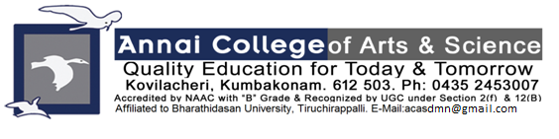
ANNAI COLLEGE OF ARTS AND SCIENCE

BHARATHIDASAN UNIVERSITY

SUPPORTING DOCUMENT
CRITERION 5.3.1

AWARDS & MEDALS IN SPORTS & CULTURAL ACTIVITIES

2020-2021

On 20.12.2020 Mr. Saranaraj, II MBA has been recorded in Magic Book of Records "Best Versatile Dancer" and he was honored by Mr. Anbalagan, MLA, Kumbakonam.
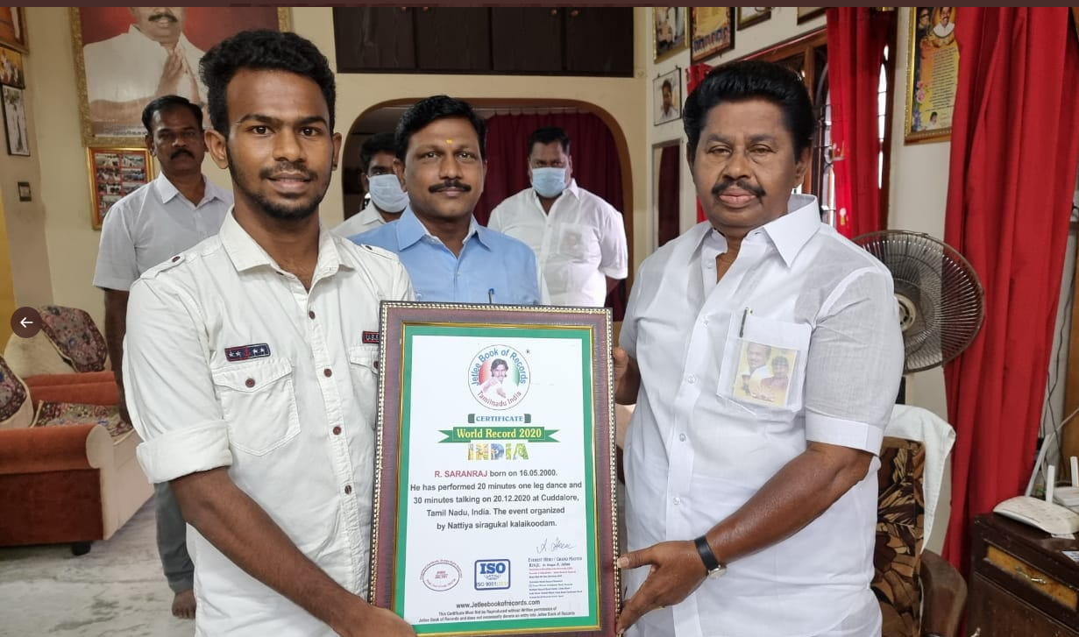
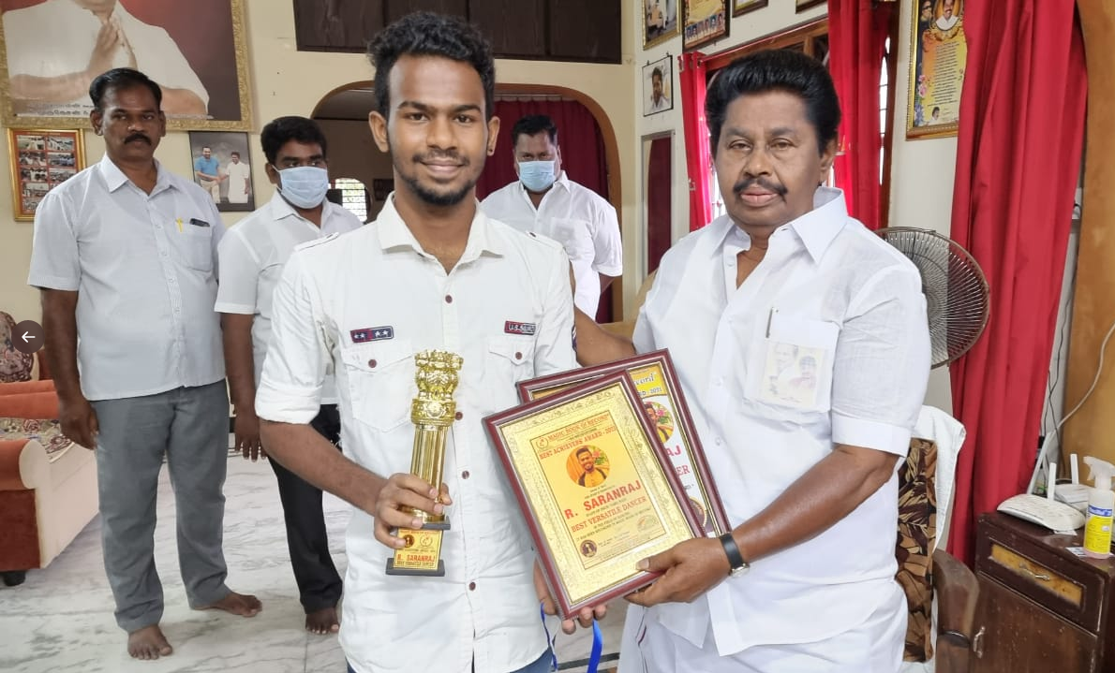

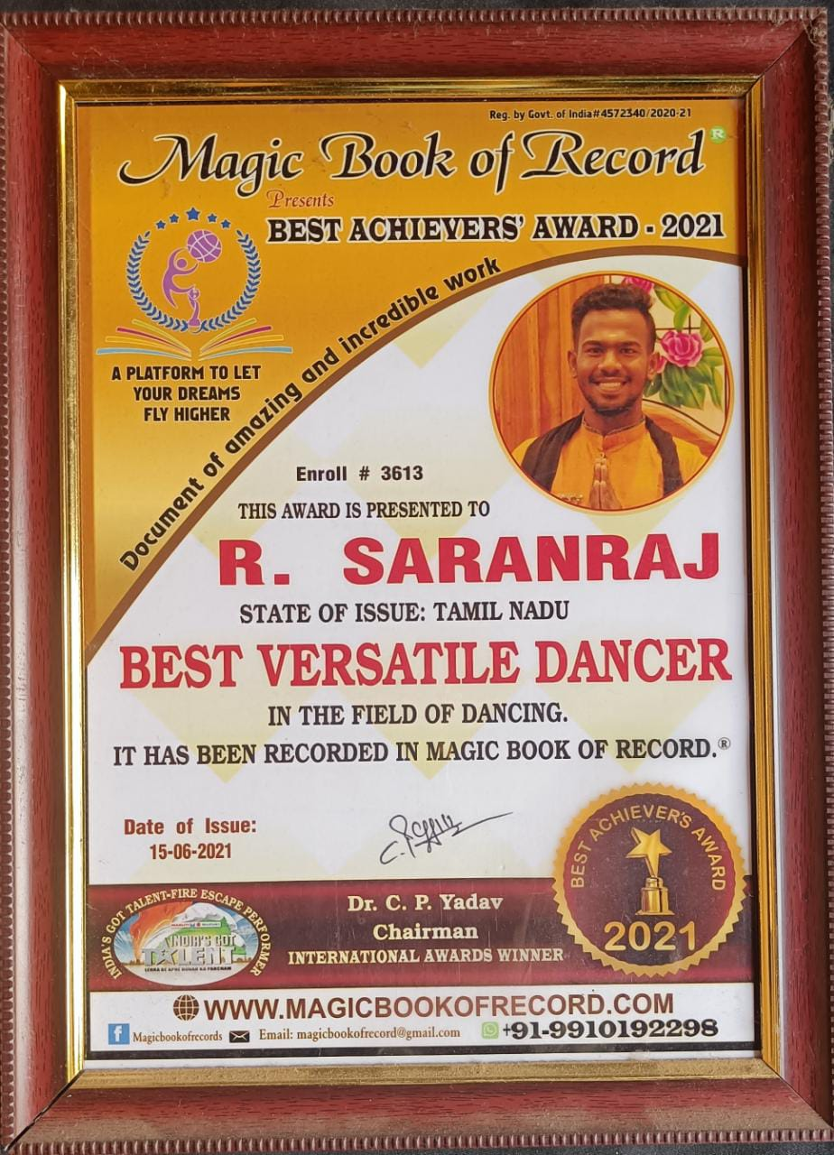

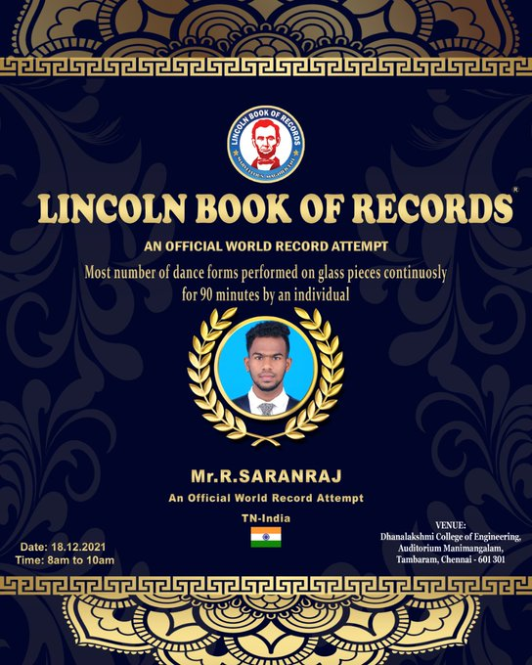

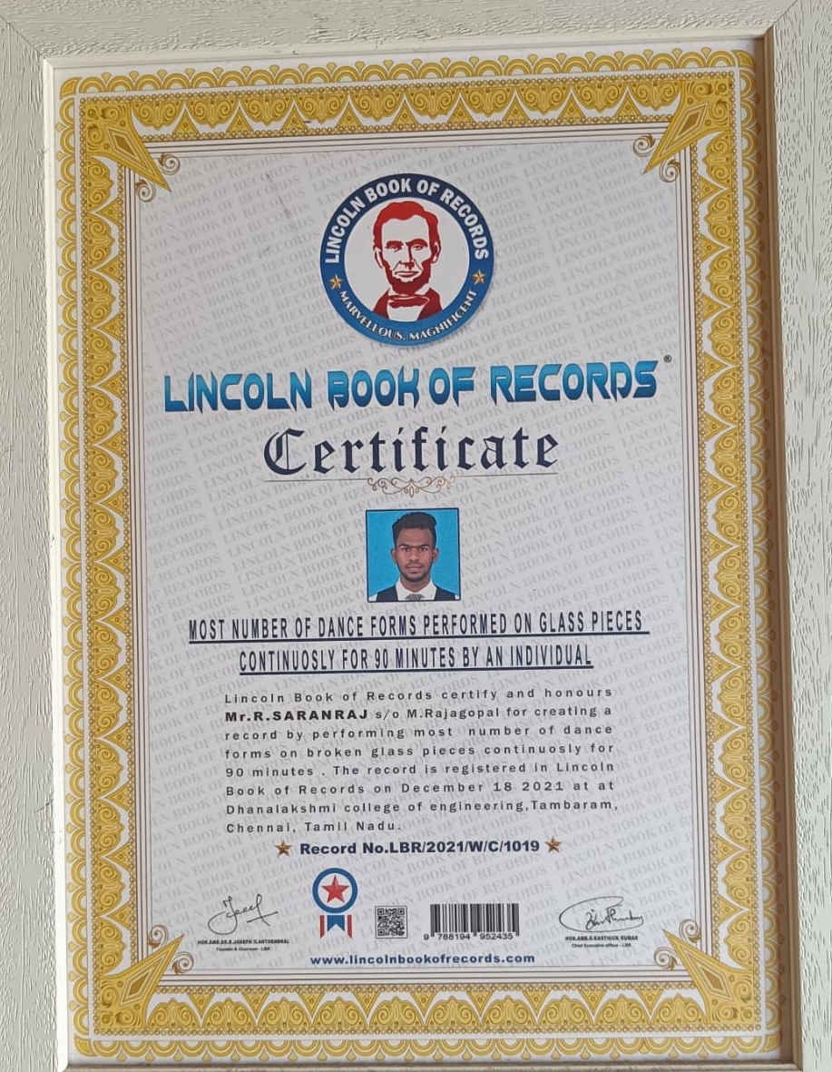
World Record 2020 for 20 minutes one leg dance and 30 minutes talking on
20-12-2020 at cuddalore

