
ANNAI COLLEGE OF ARTS AND SCIENCE

BHARATHIDASAN UNIVERSITY

SUPPORTING DOCUMENT
CRITERION 5.3.2

Presence of an Active Student Council & Representation of Students on Academic & Administrative Bodies/Committees of the Institution

2020-2021

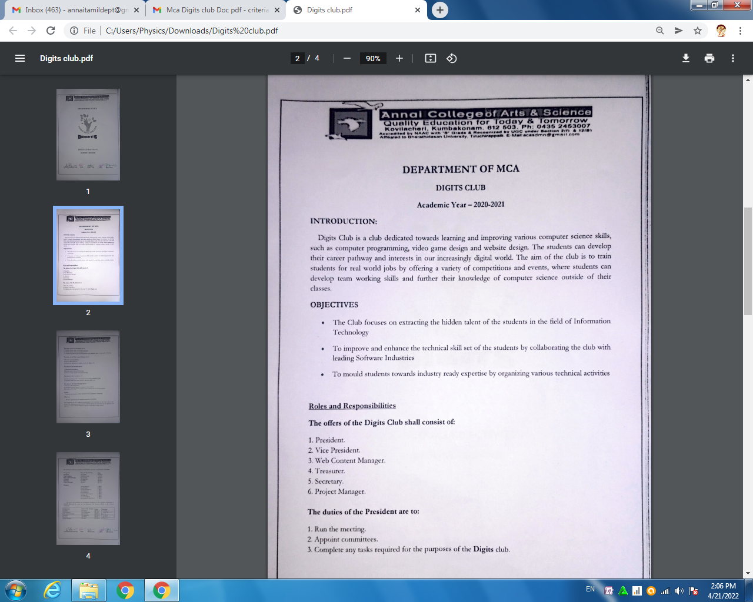

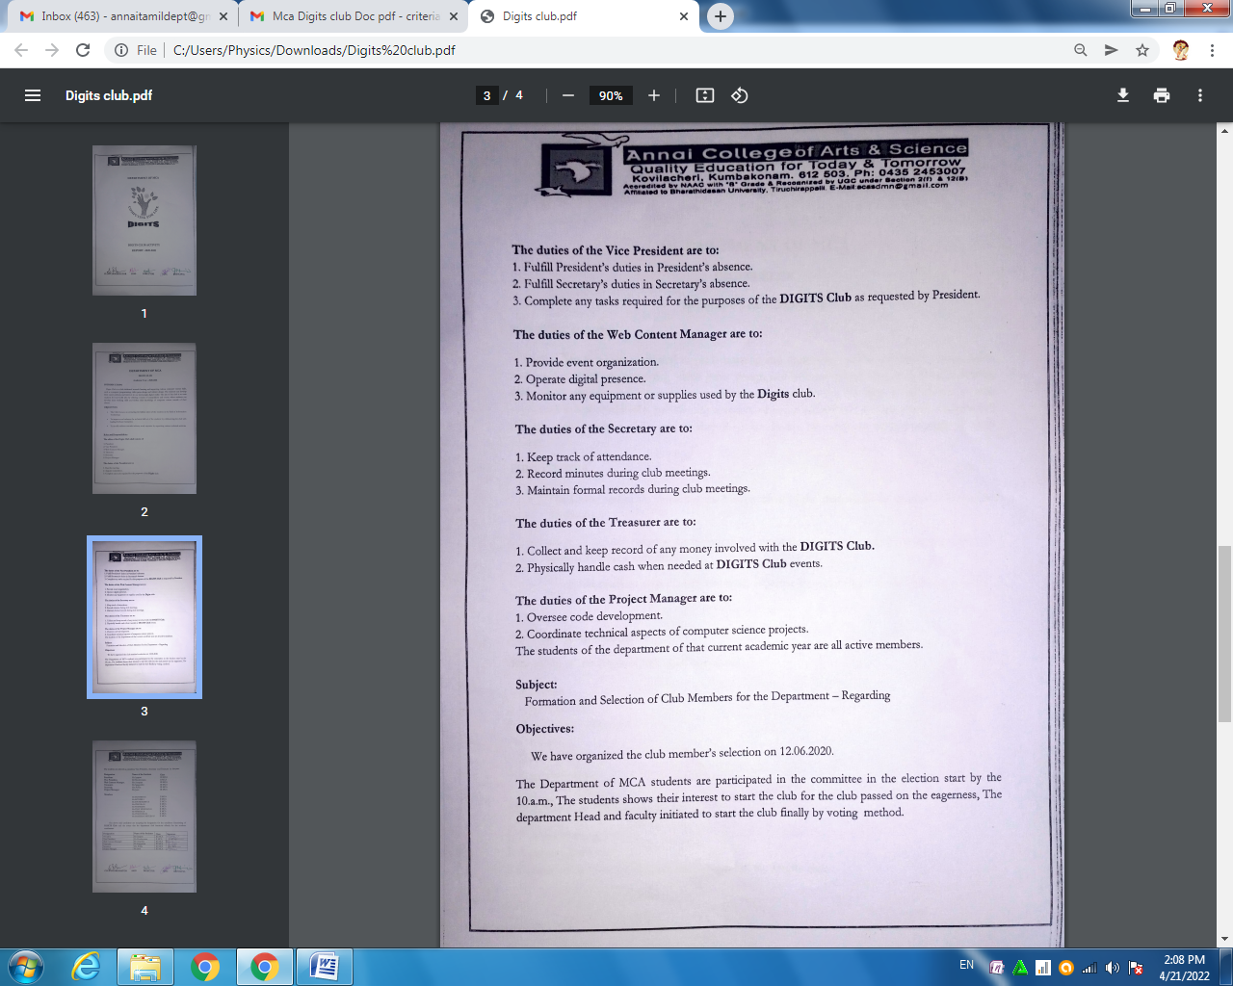

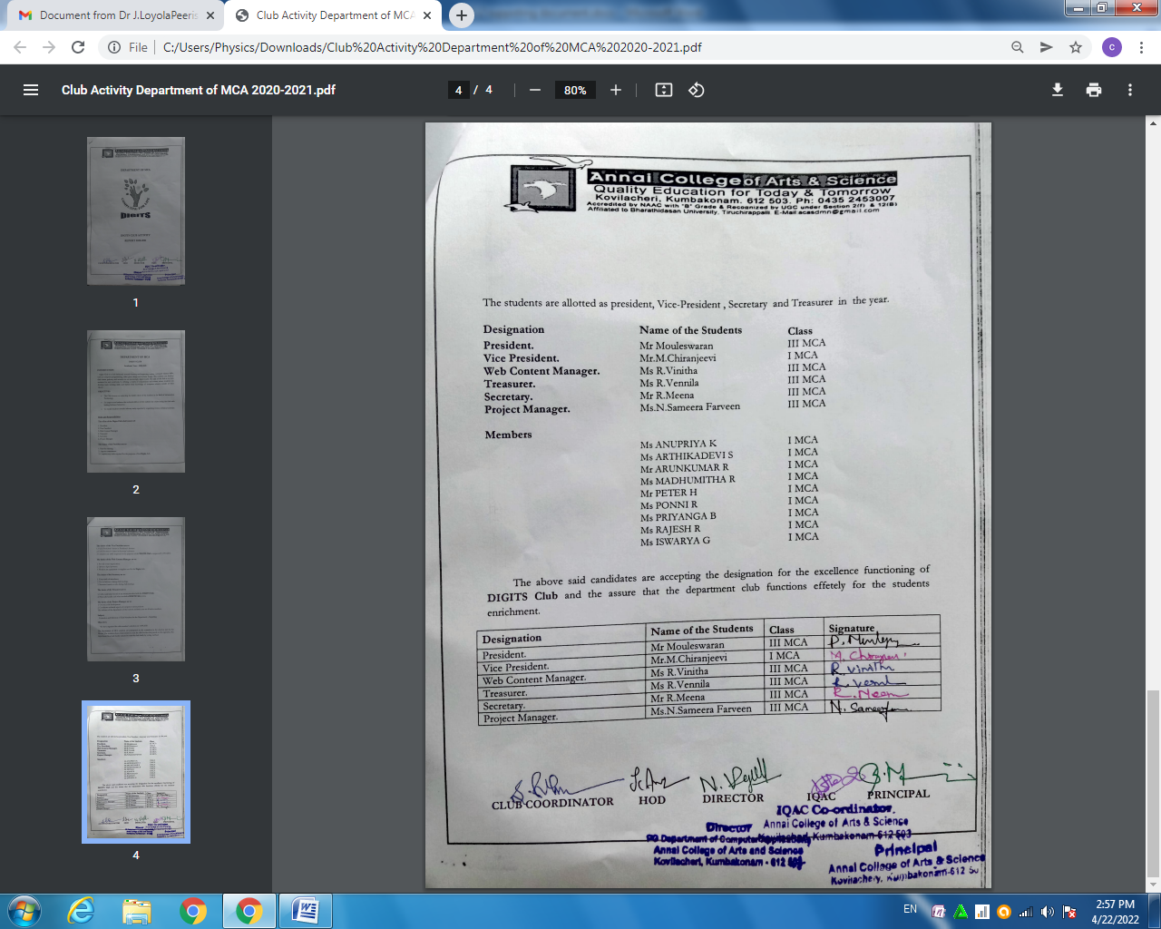

DEPARTMENT OF BHM CLUB MEMBERS LIST

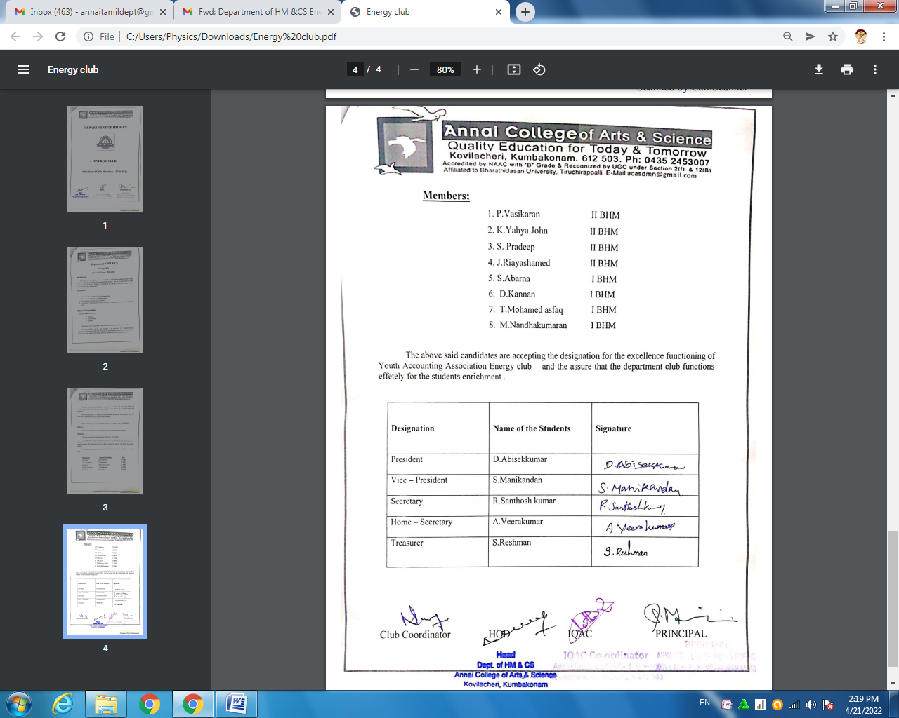

DEPARTMENT OF BBA CLUB MEMBERS LIST

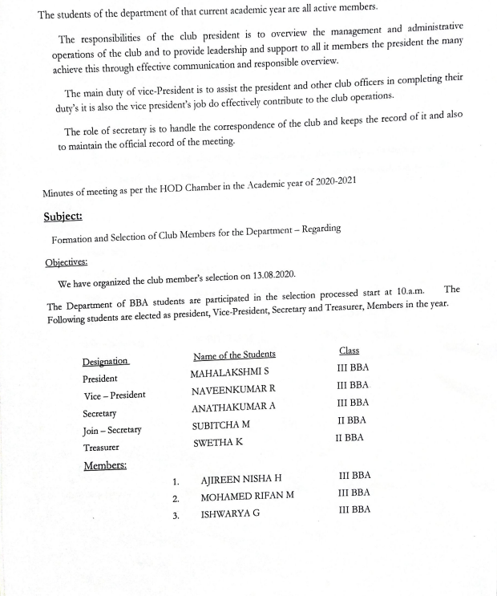

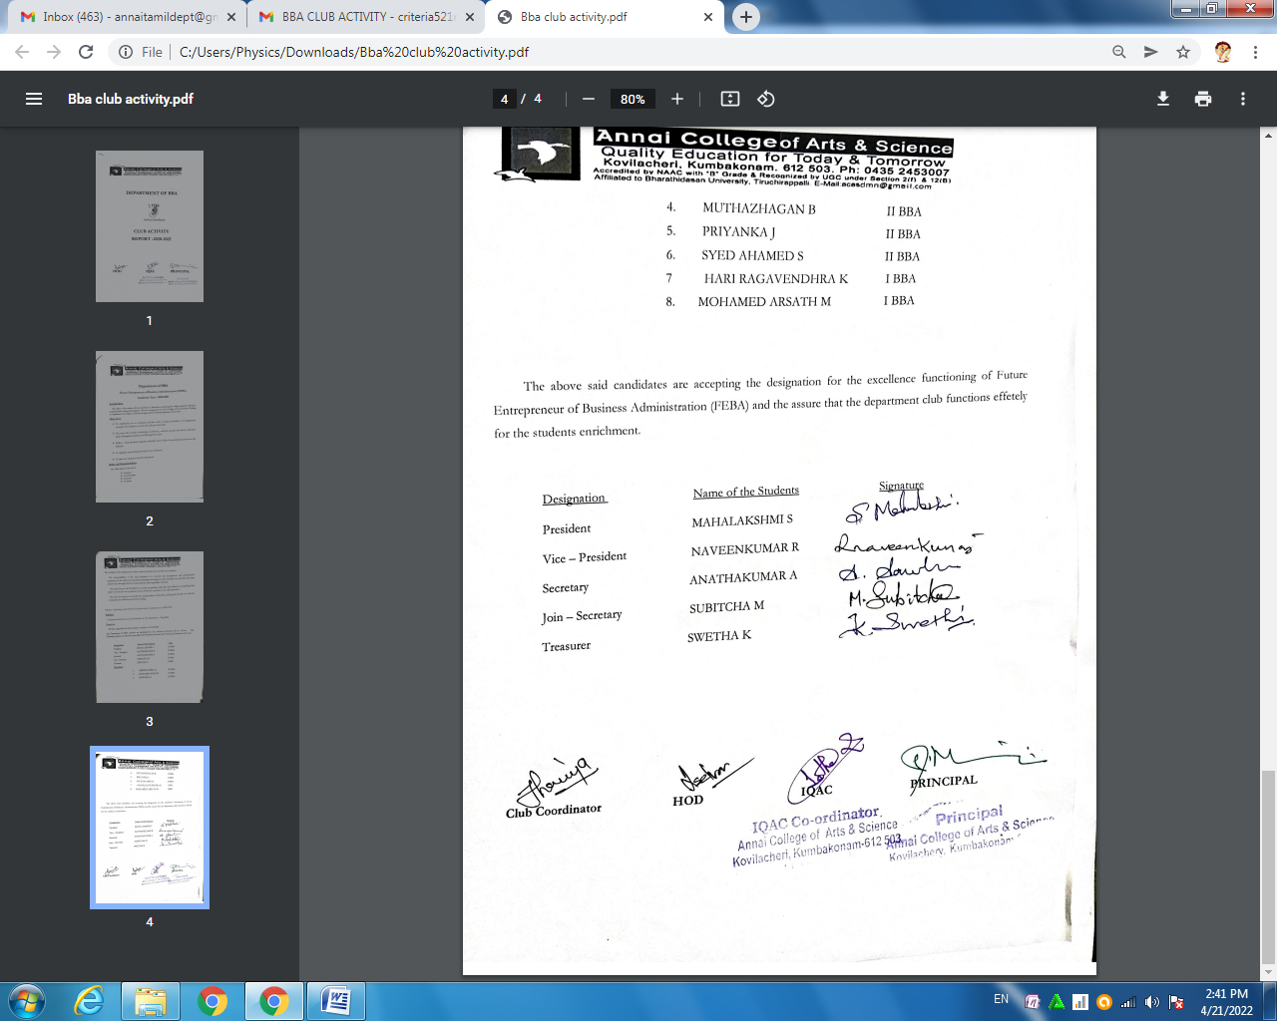

DEPARTMENT OF BIO - SCIENCE CLUB MEMBERS LIST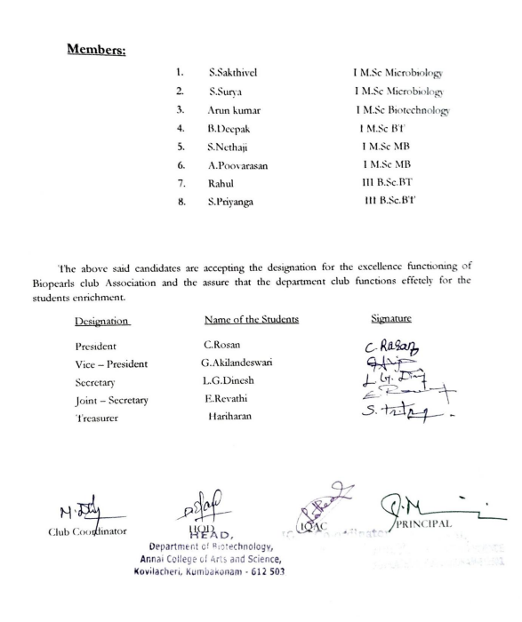

DEPARTMENT OF CHEMISTRY CLUB MEMBERS LIST
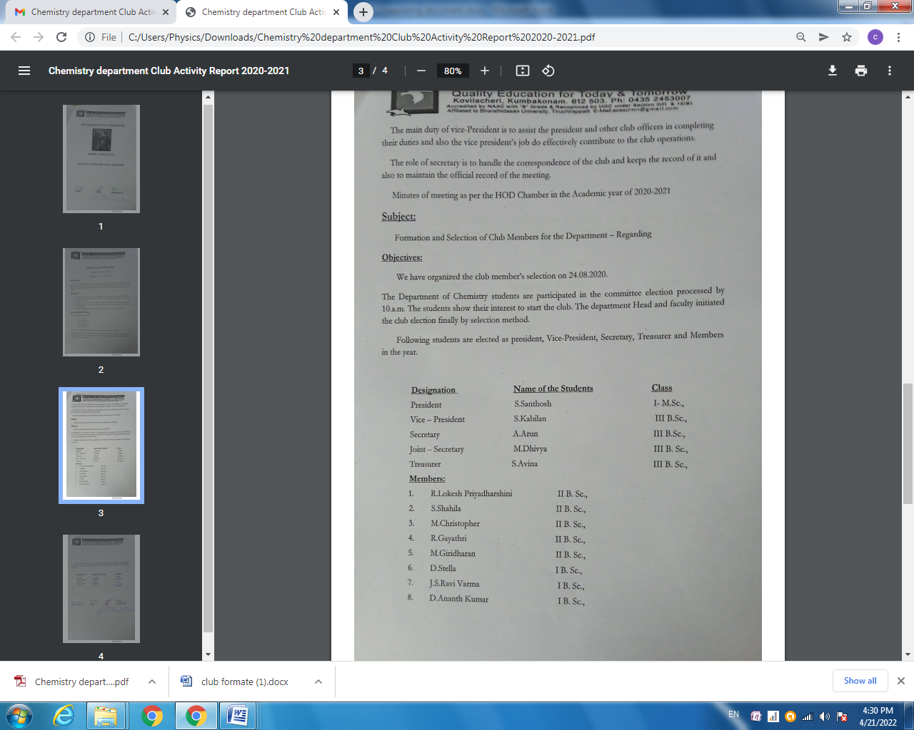

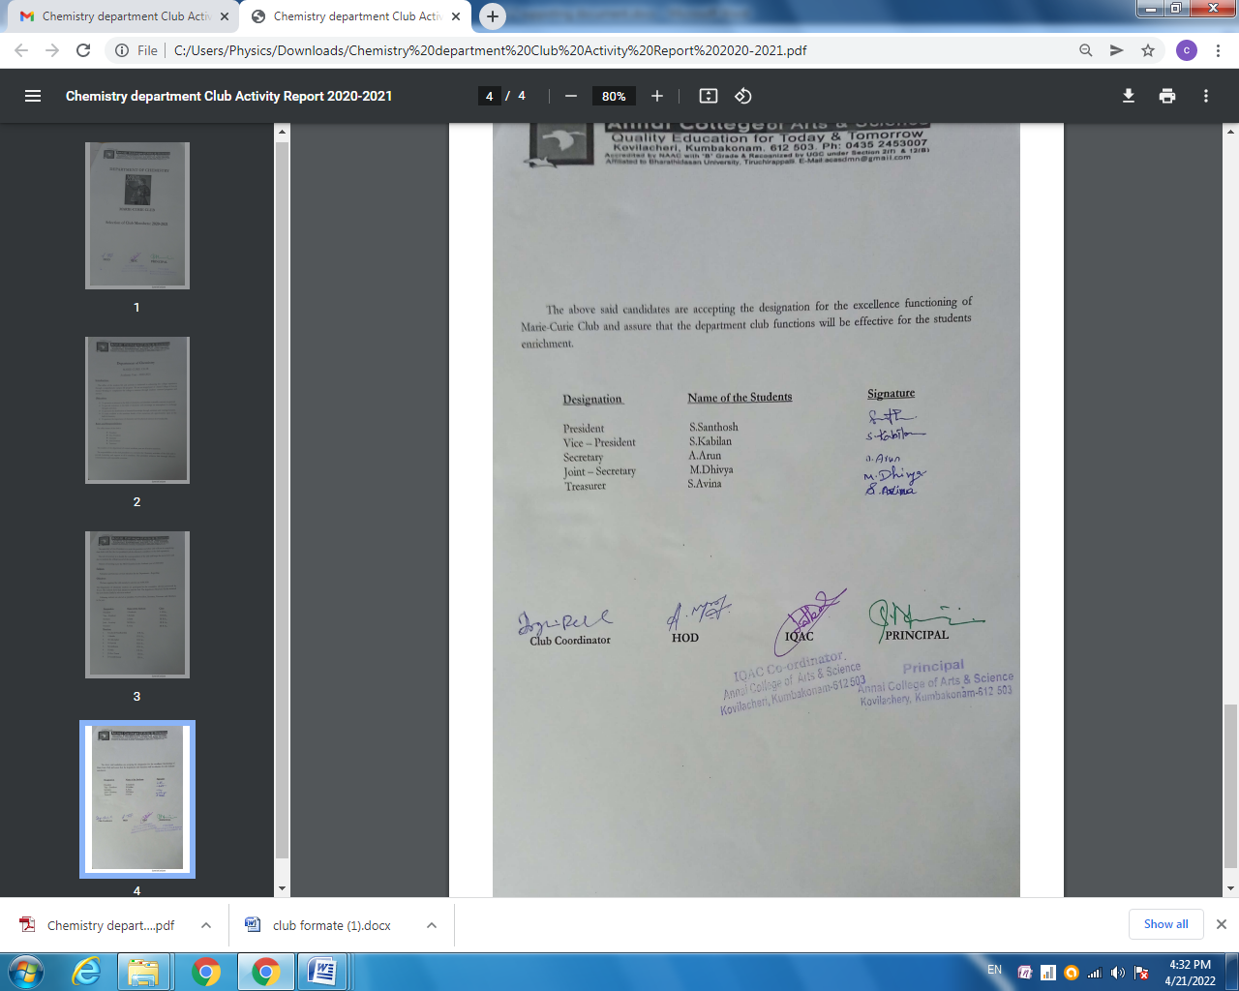
DEPARTMENT OF MATHEMATICS CLUB MEMBERS LIST

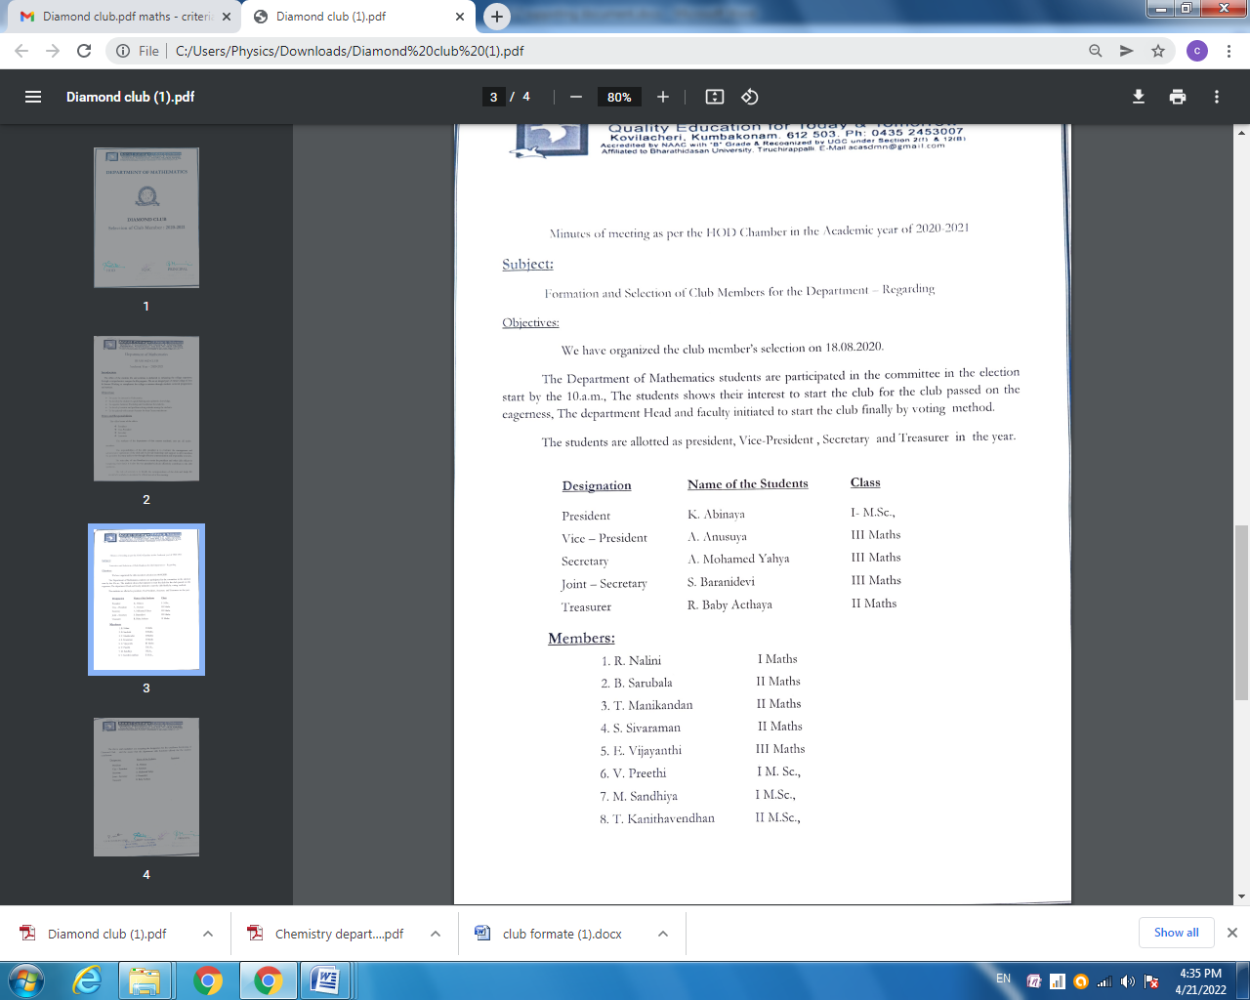

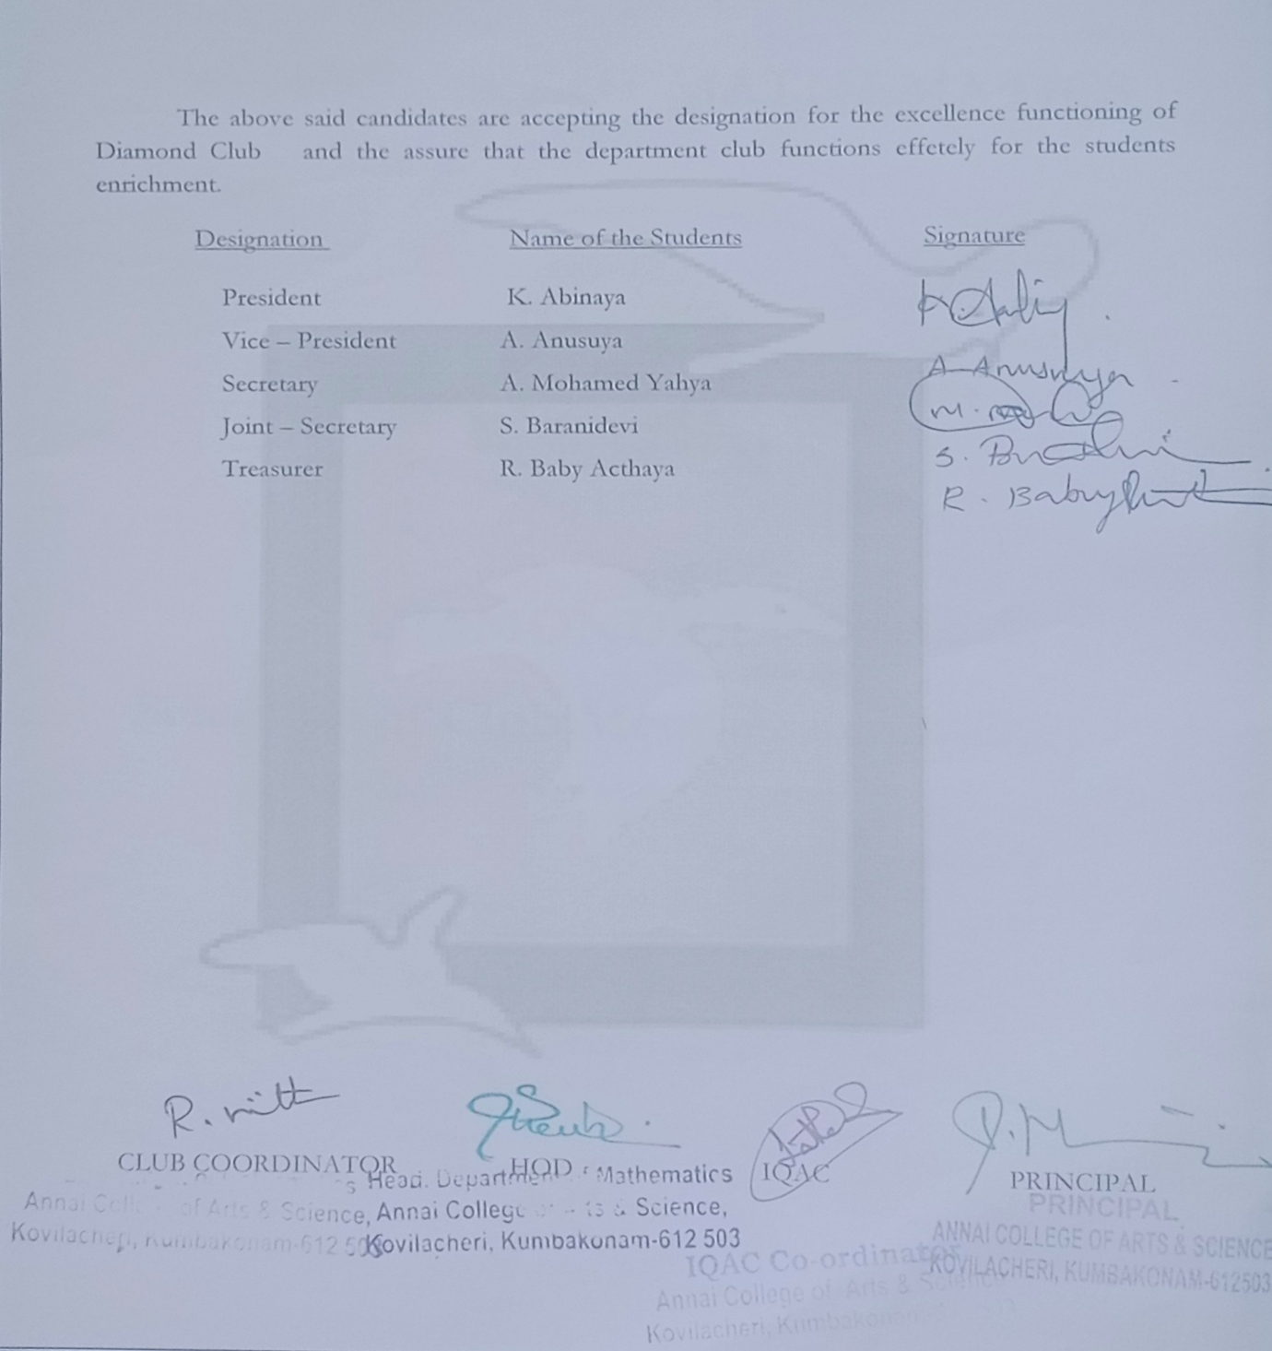

DEPARTMENT OF DEFENCE CLUB MEMBERS LIST

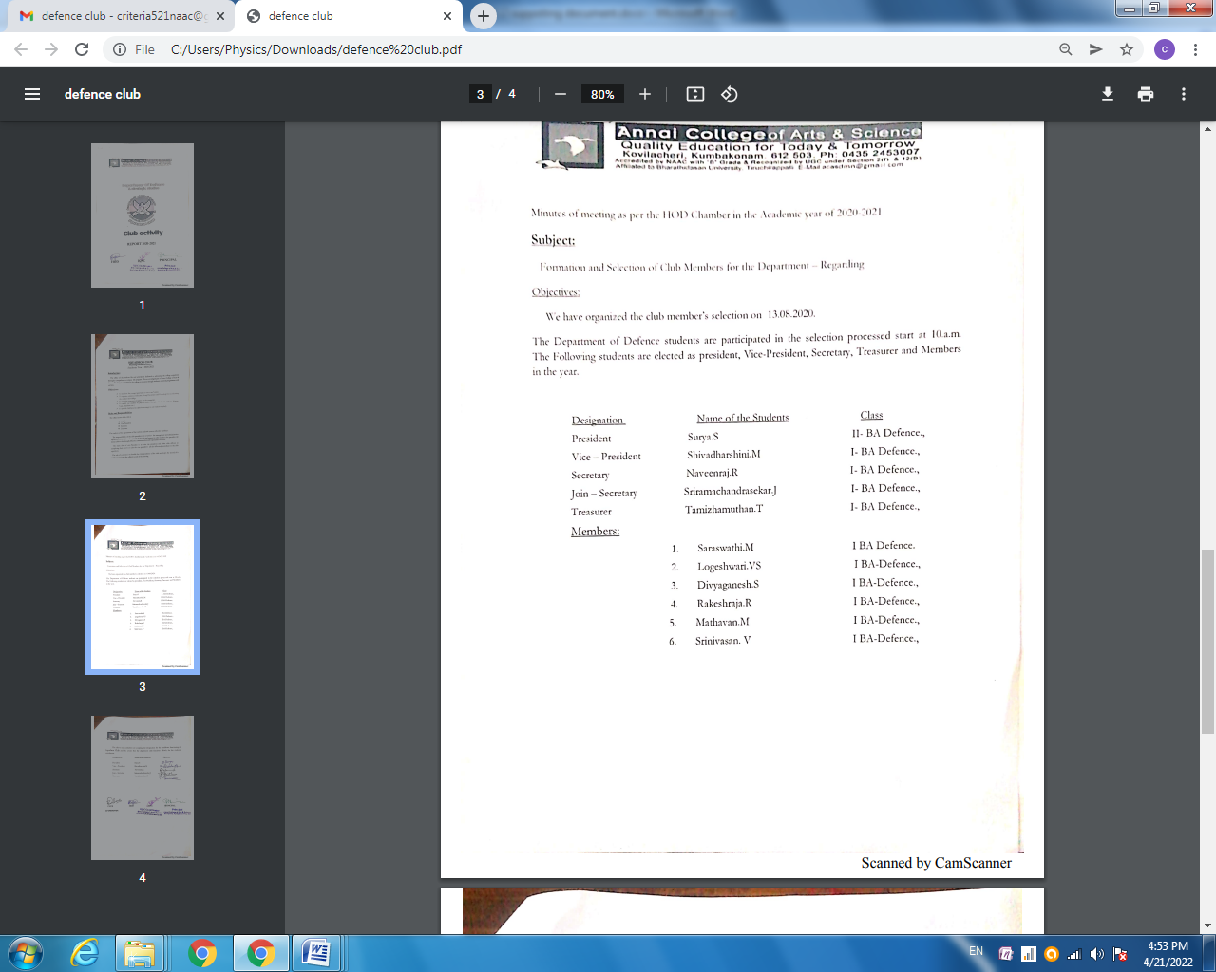

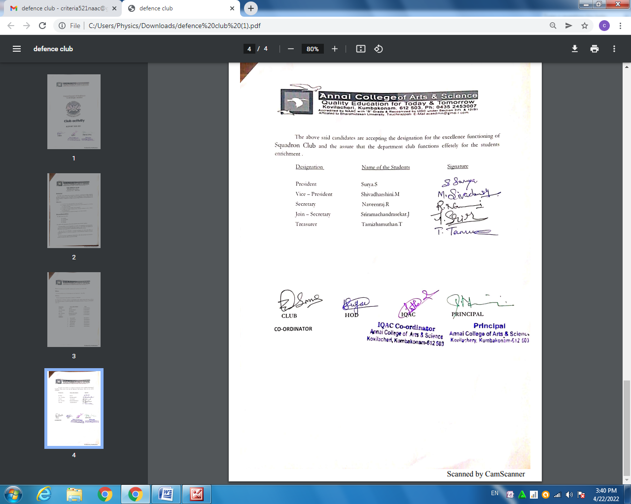

DEPARTMENT OF ENGLISH CLUB MEMBERS LIST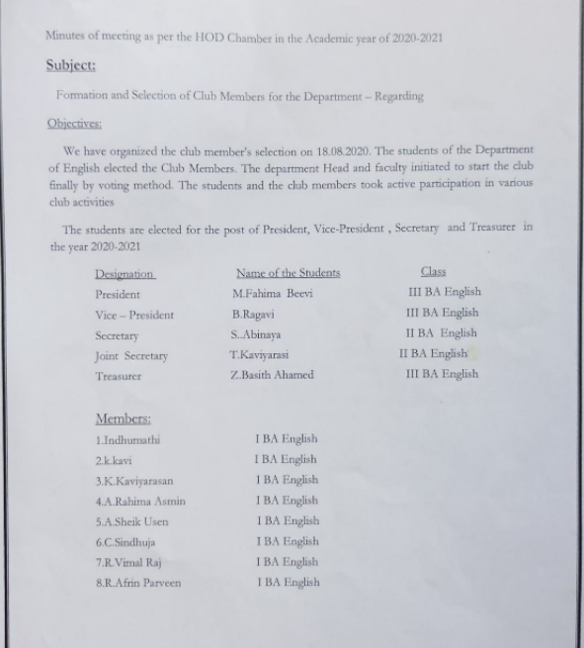

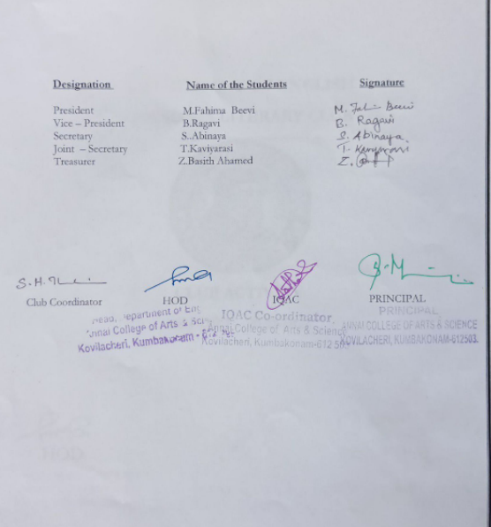

DEPARTMENT OF COMMERCE CLUB MEMBERS LIST

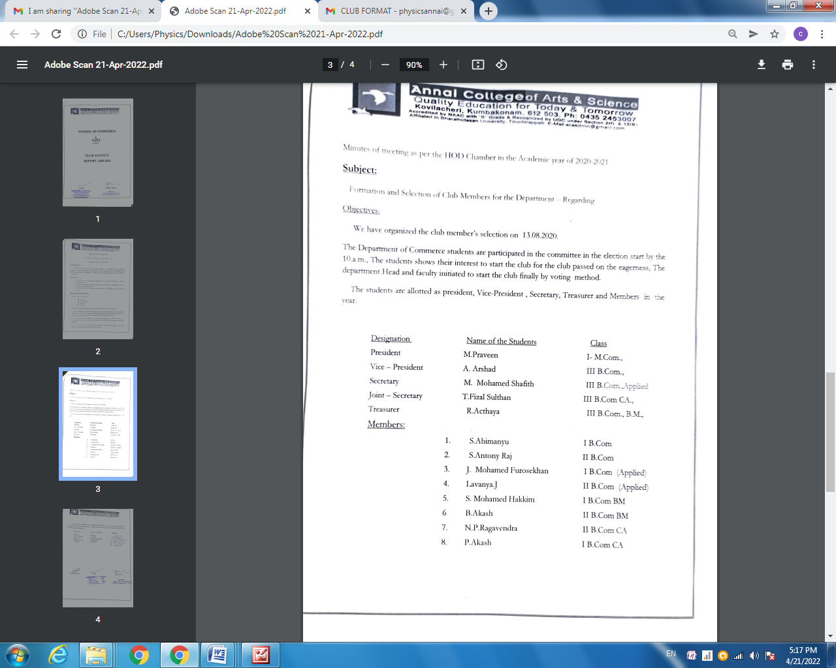

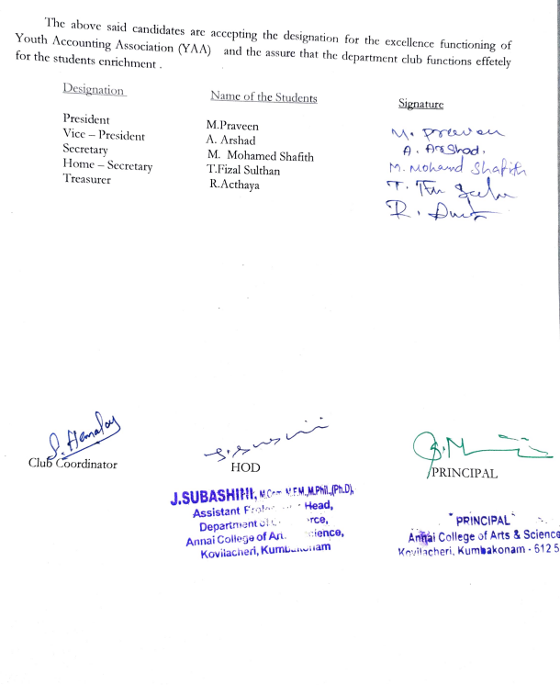
DEPARTMENT OF TAMIL CLUB MEMBERS LIST

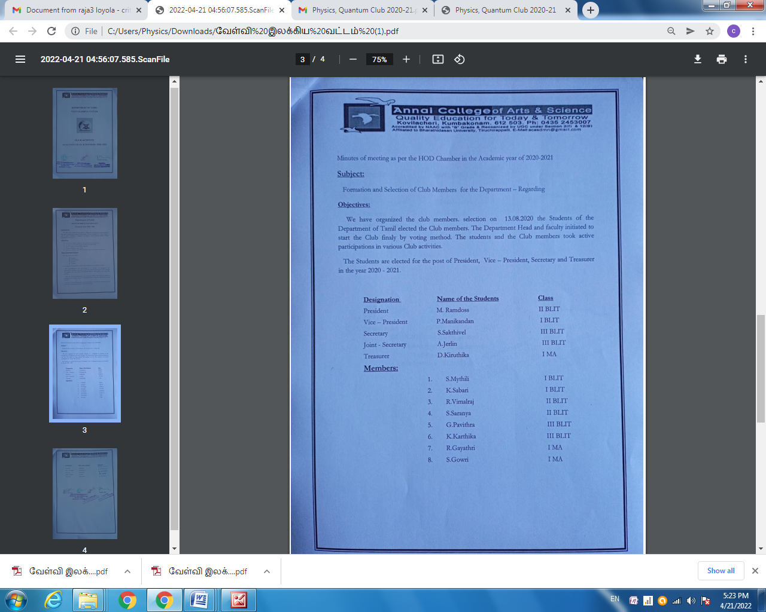

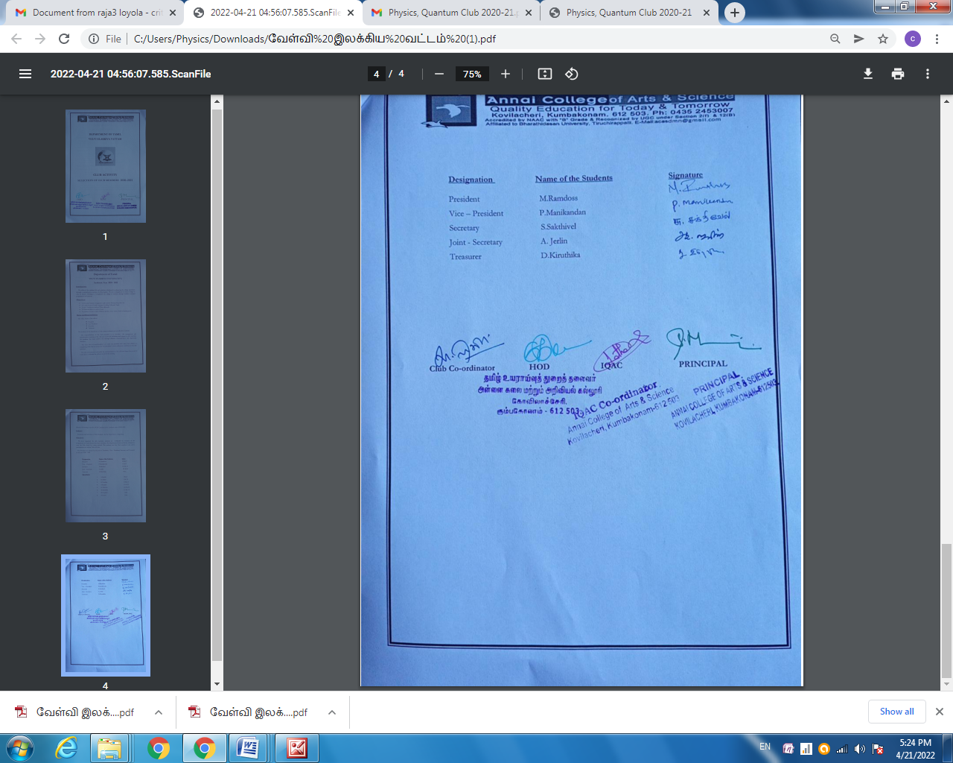

DEPARTMENT OF PHYSICS CLUB MEMBERS LIST