ANNAI COLLEGE OF ARTS AND SCIENCE

BHARATHIDASAN UNIVERSITY

SUPPORTING DOCUMENT
CRITERION 5.3.3

Sports & Cultural Activities in which the Students of the Institution have participated in the Year 2020-21 (Organised by the Institution/Other Institutions)

Sports & Cultural

2020-2021
Annai Kalai Siragual for the year 2020-2021
Our Annai College of Arts and Science,Kalai Siragual students Miss.Sowmiya, Miss.Aruna Devi, Mr. Saranraj, Mr. Yuvanderian, Miss. Thilagavathy, Miss.Vishali Priya had won the First Prize of Rs.25,000 at IRTT Engineering College, Erode organized by IRTT Alumni students on Feb’2021.

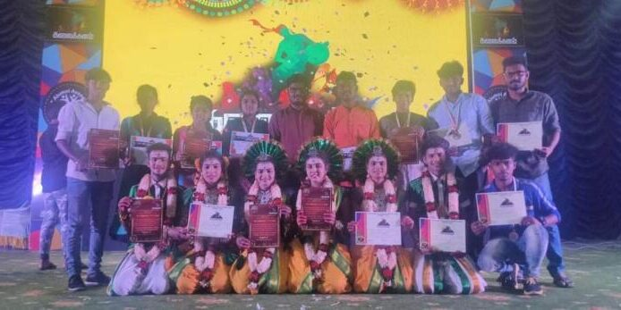

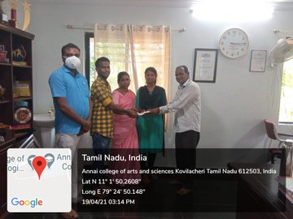

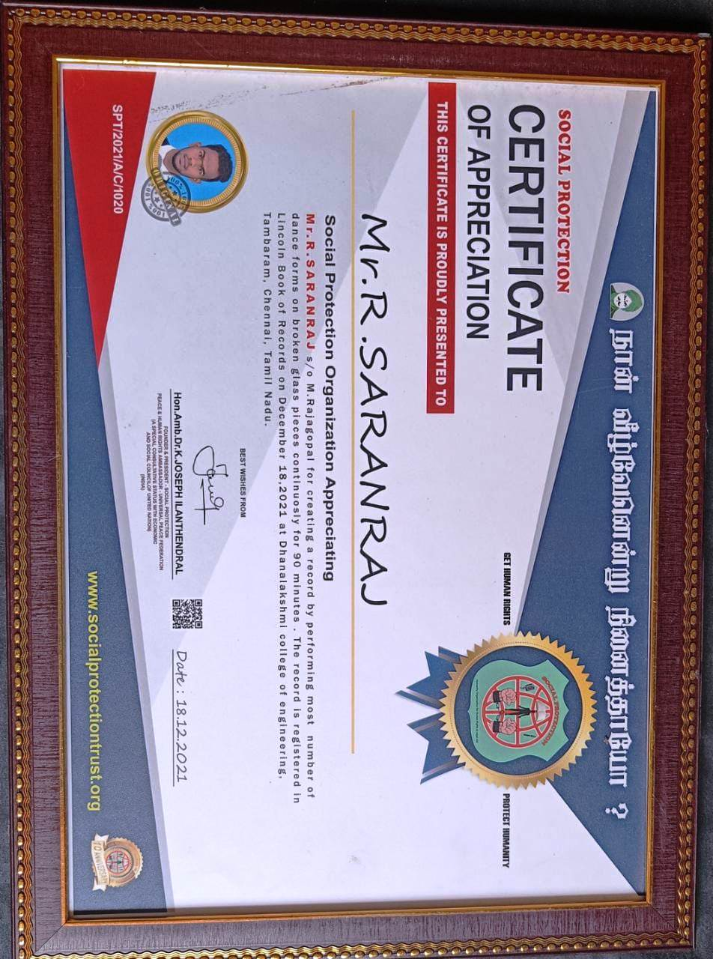

Best Voicing Award -2021

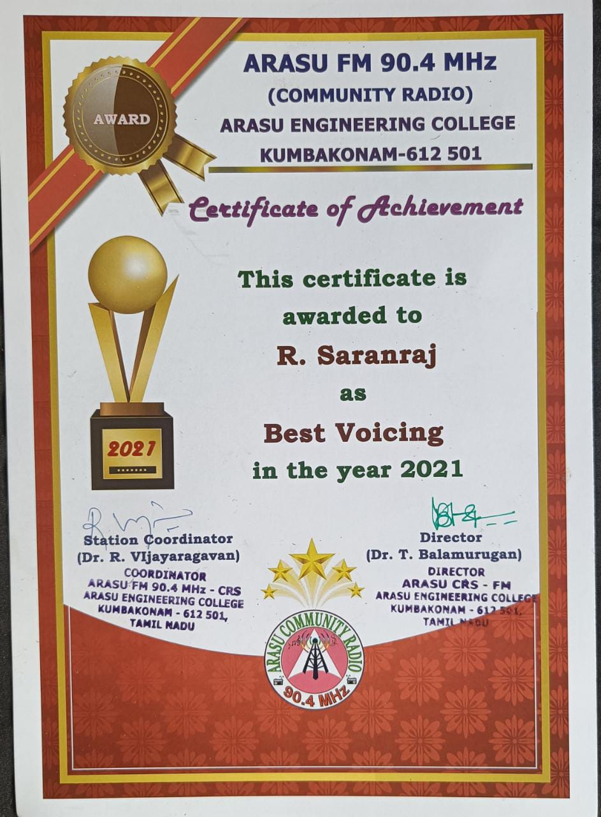

Certificate for Traditional Folk Dance

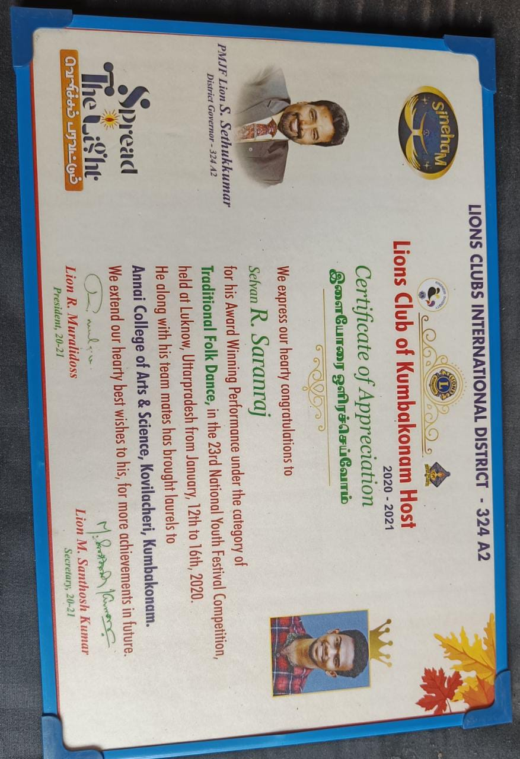

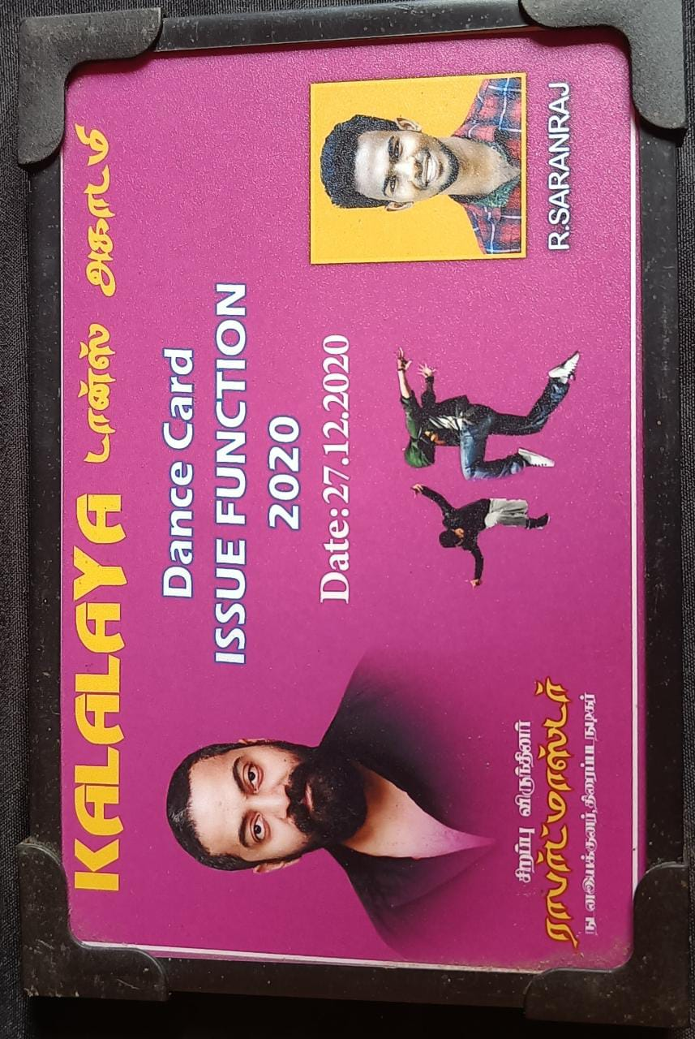

Certificate For Best Voicing -2021 at Arasu Engineering College - Kumbakonam

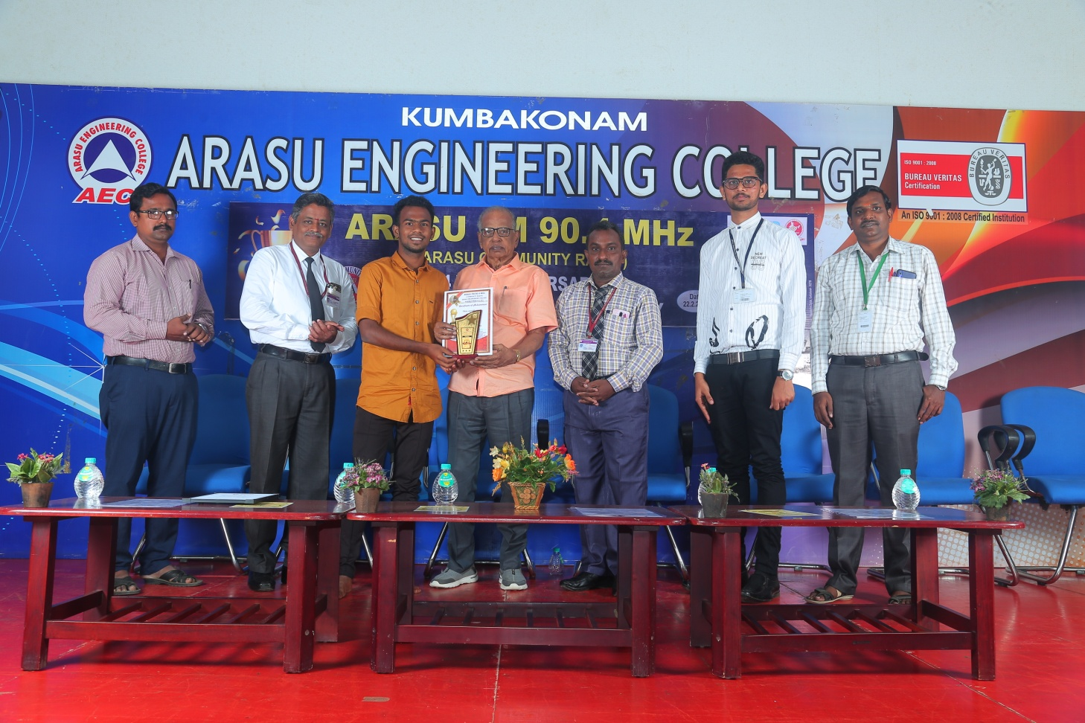

SPORTS 2020-2021
Our Annai College of Arts and Science Sports Male Students had Won the Volley Ball Match at Bharathidasan Unversity, Thiruchrapalli on 10TH December 2021.

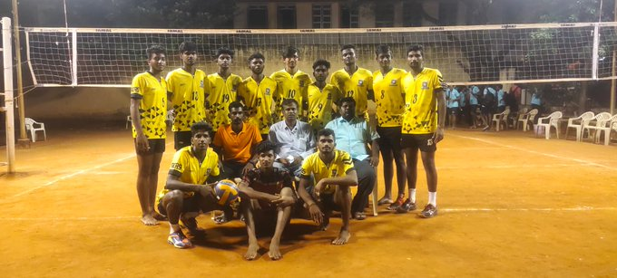

Certificate for Sports Students had Won the Volley Ball Match at Bharathidasan Unversity, Thiruchrapalli on 10TH December 2021.
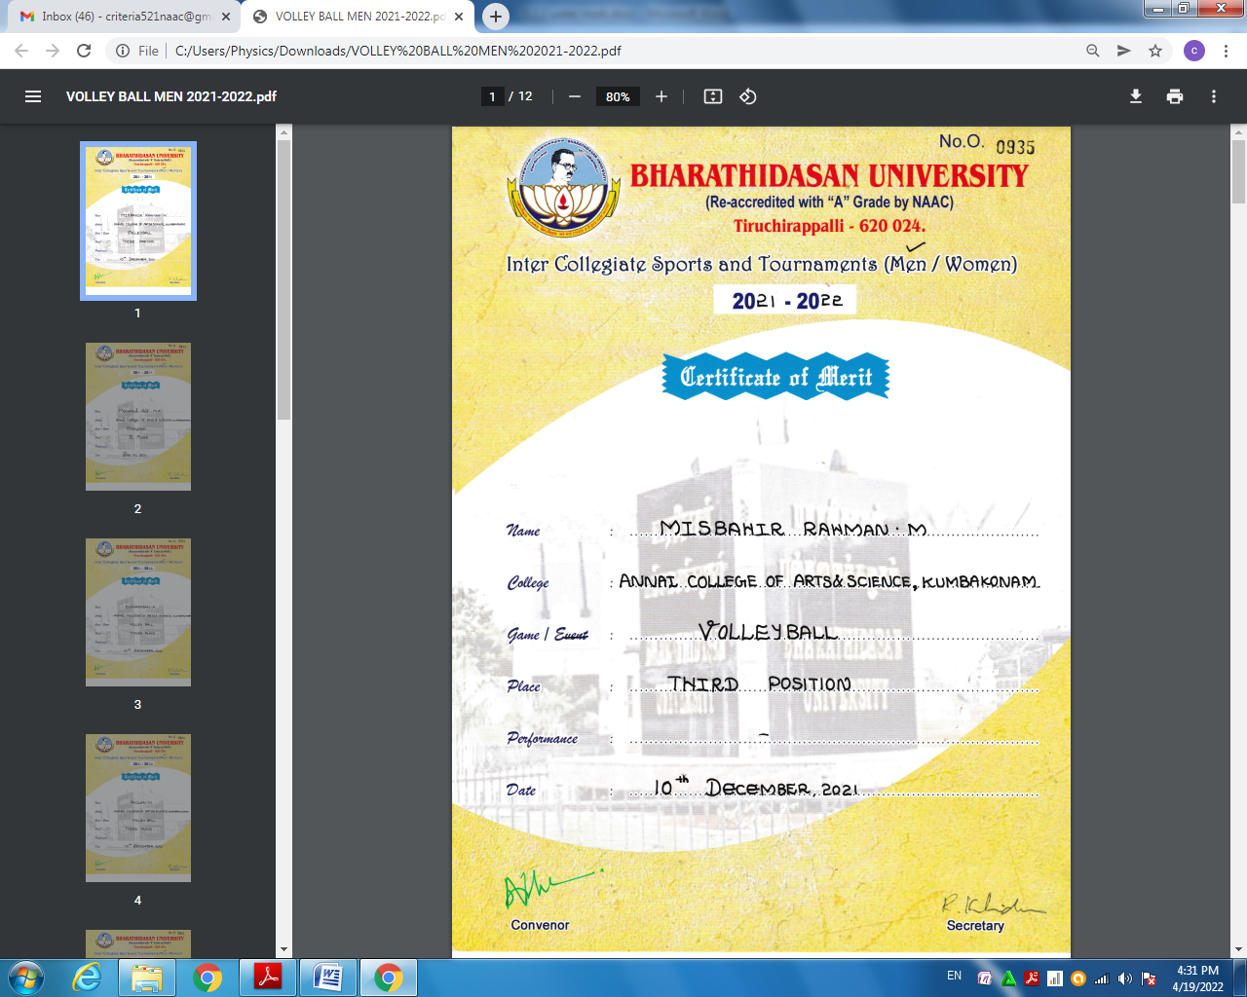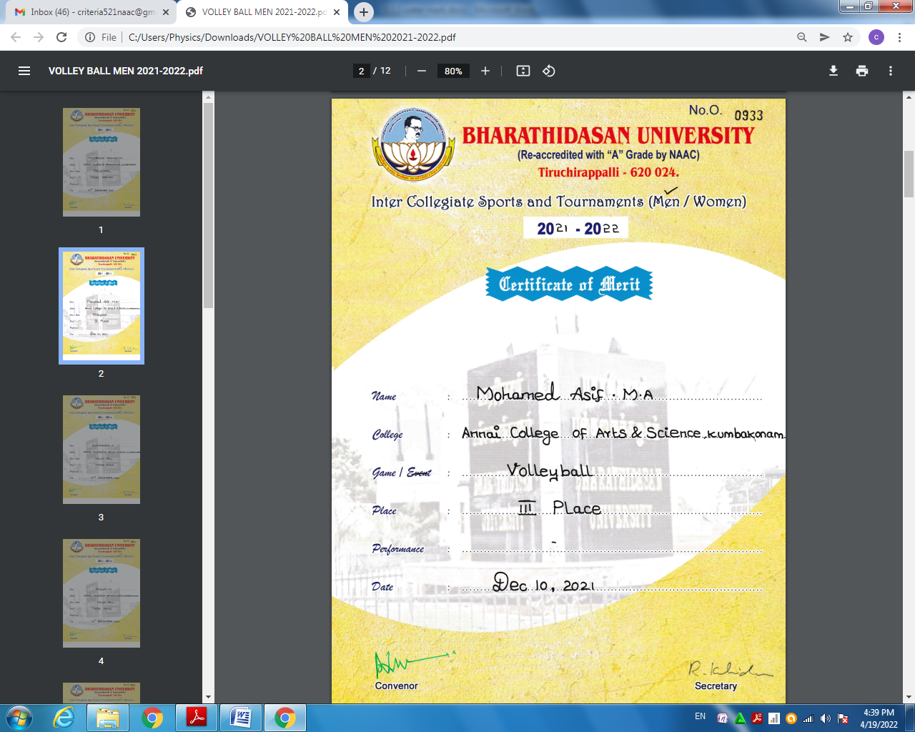

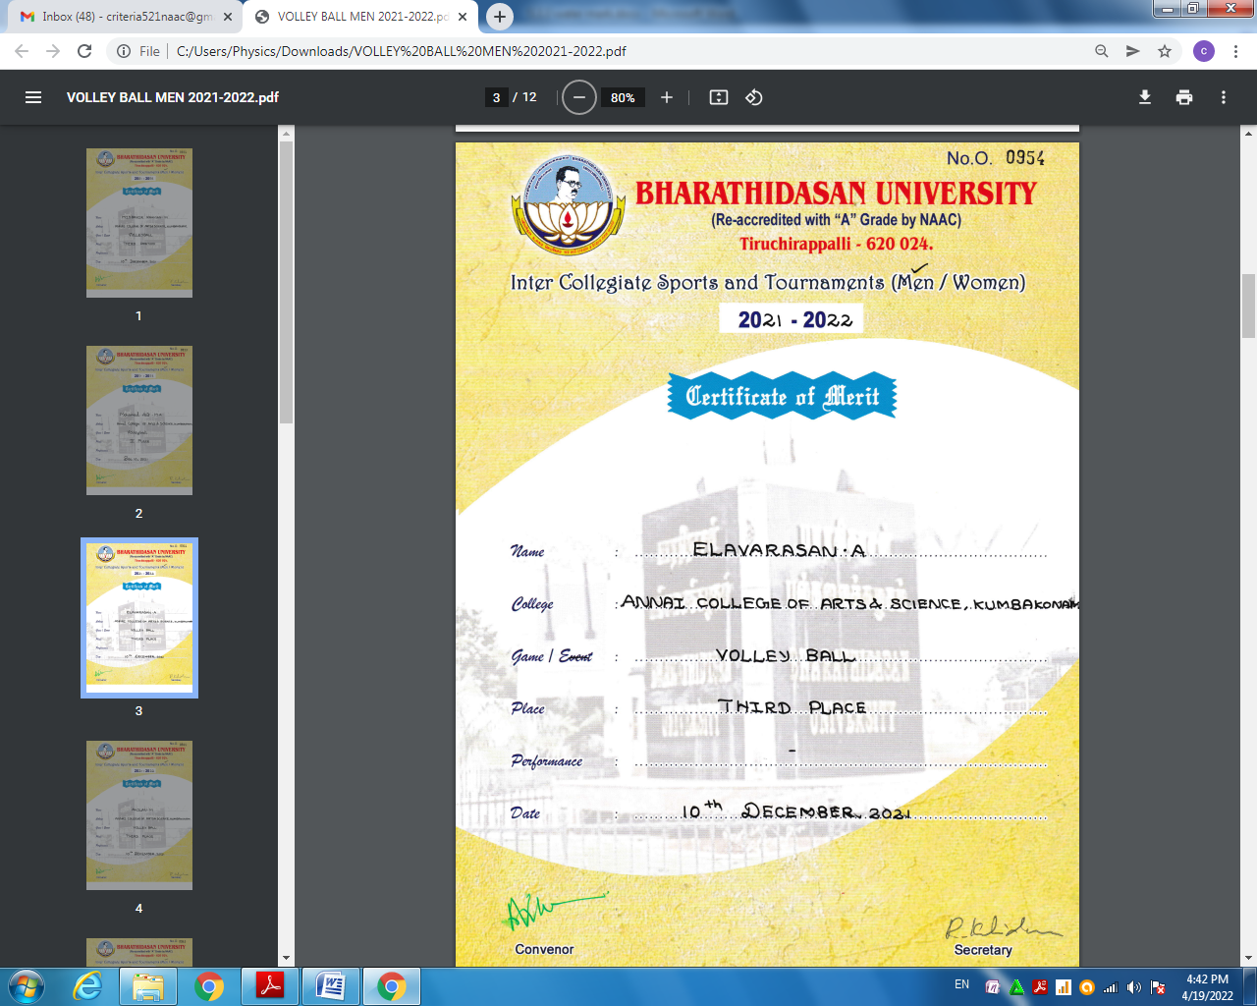

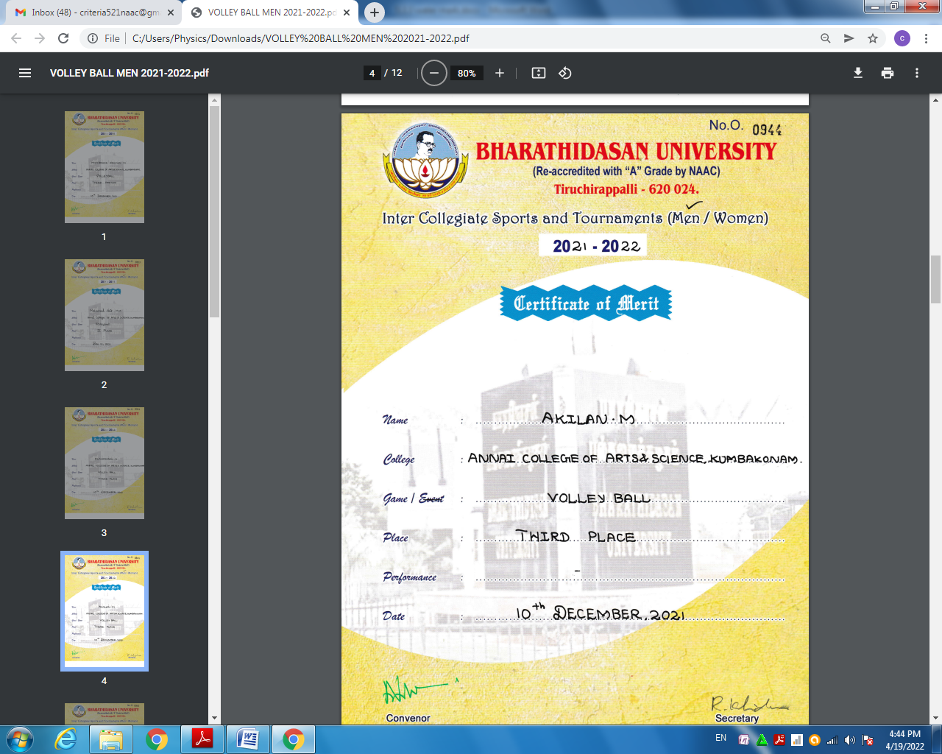
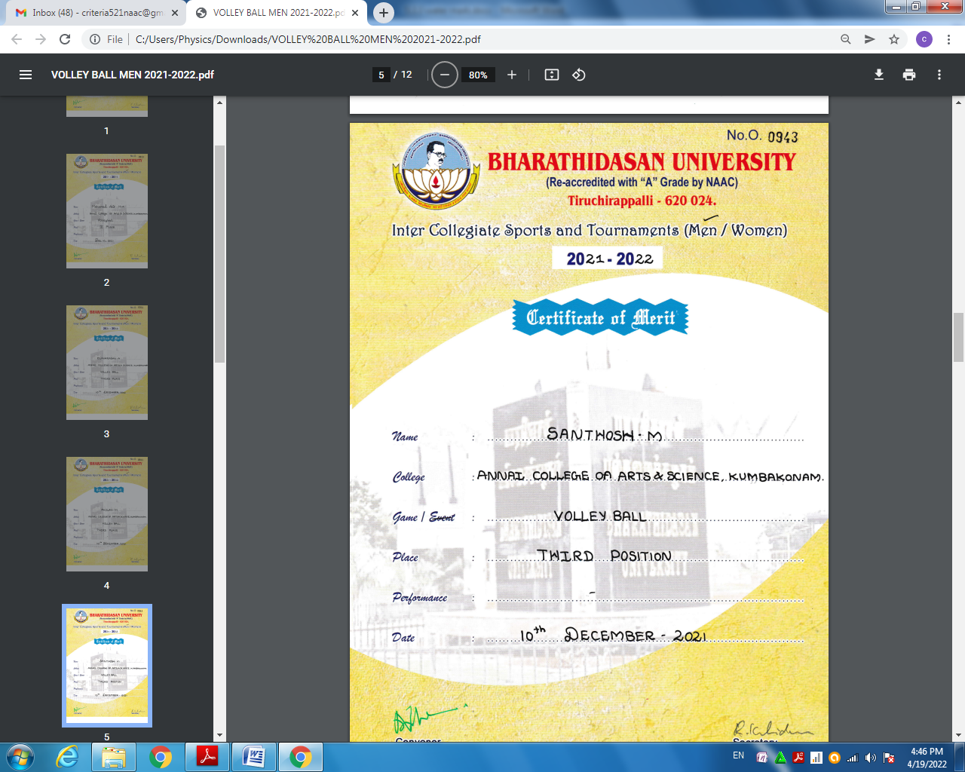

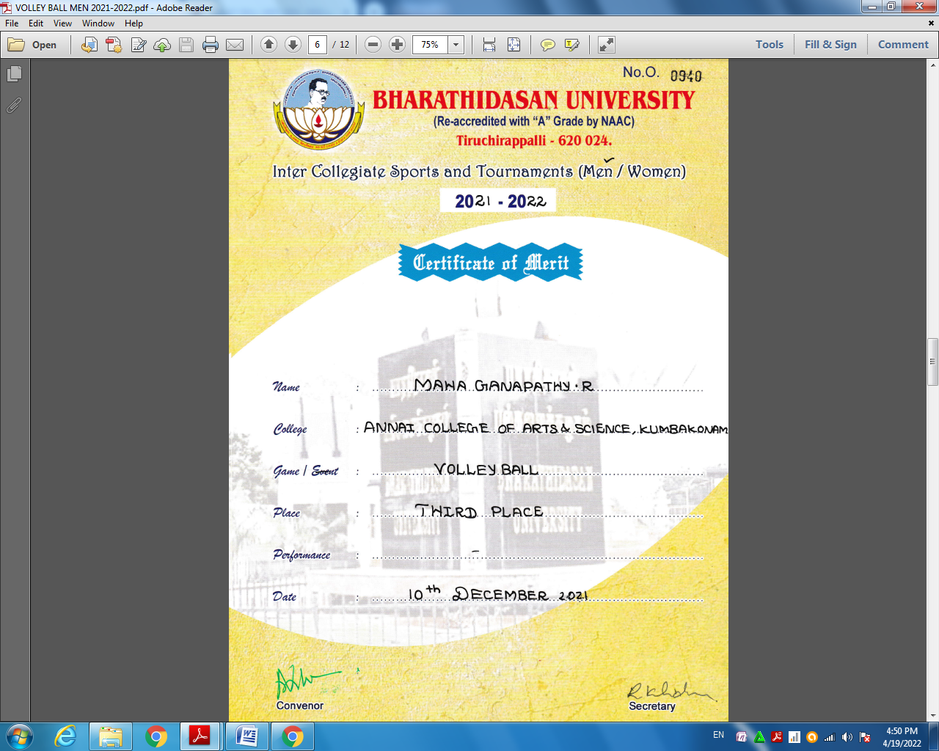
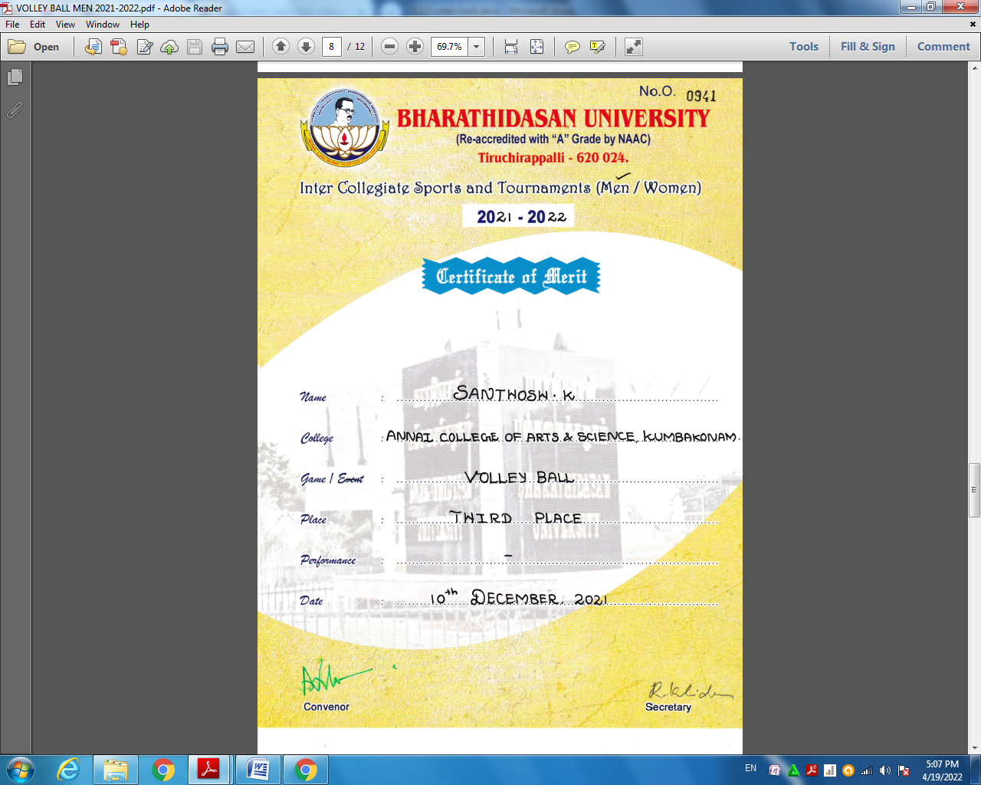
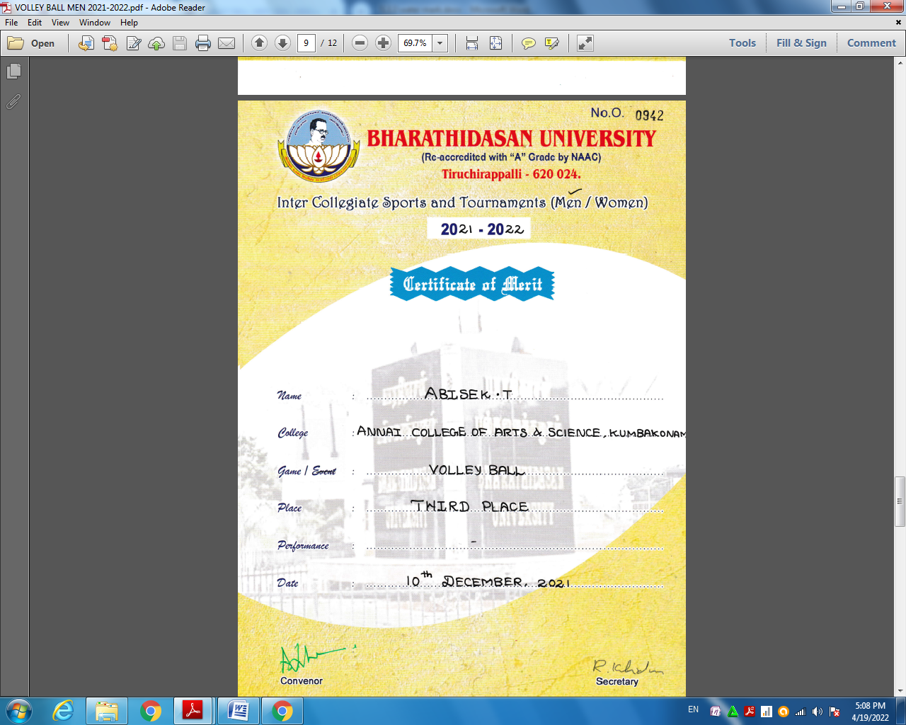

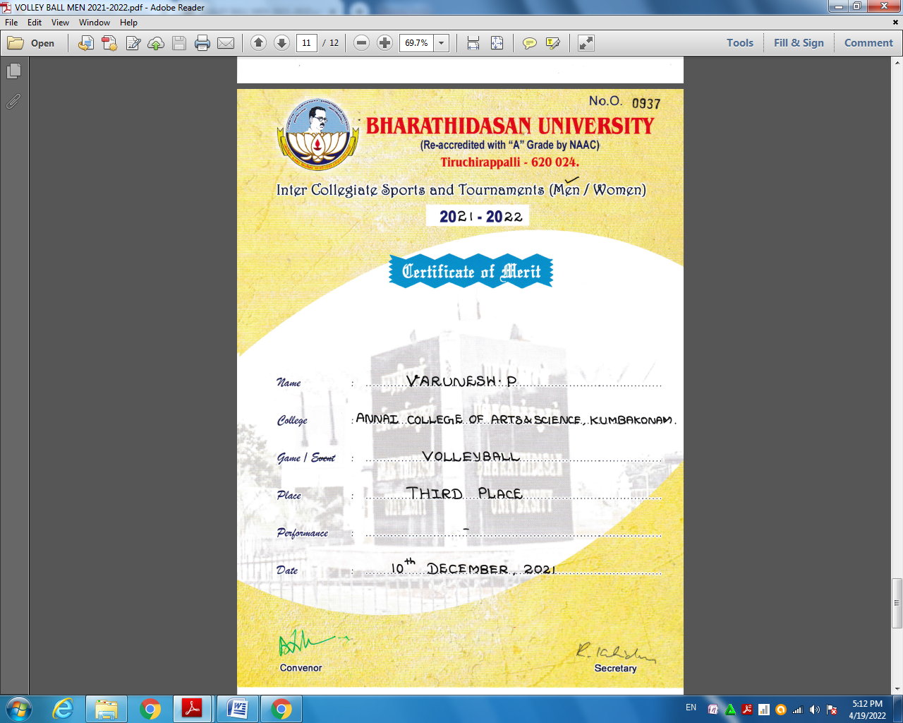
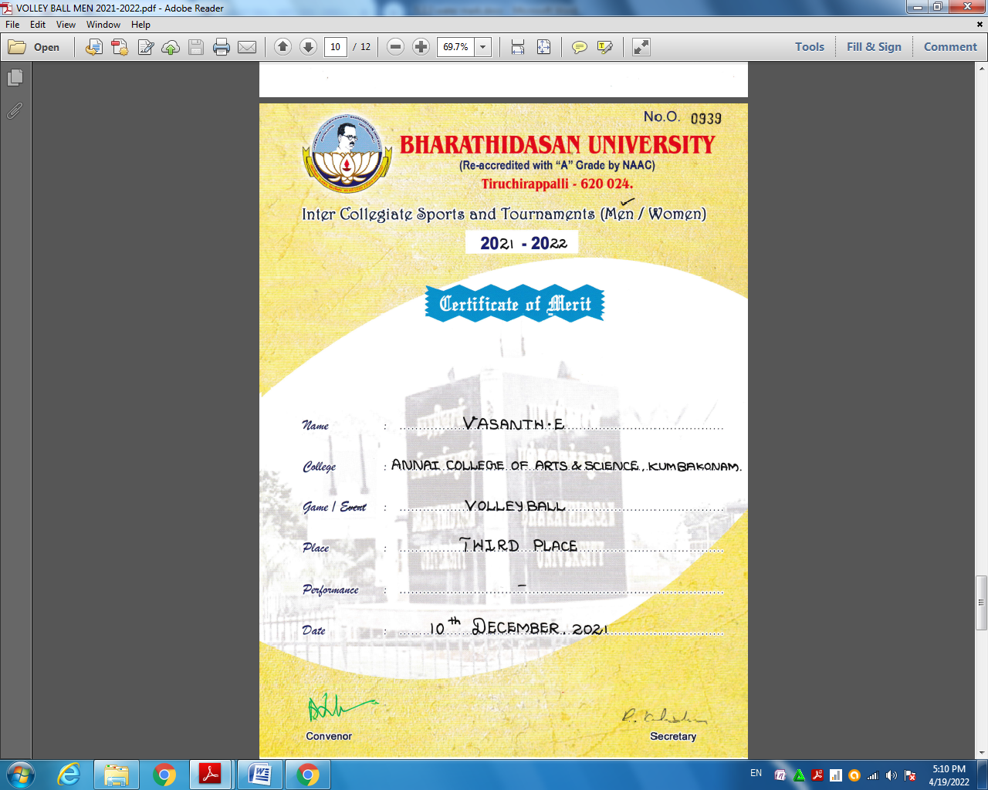

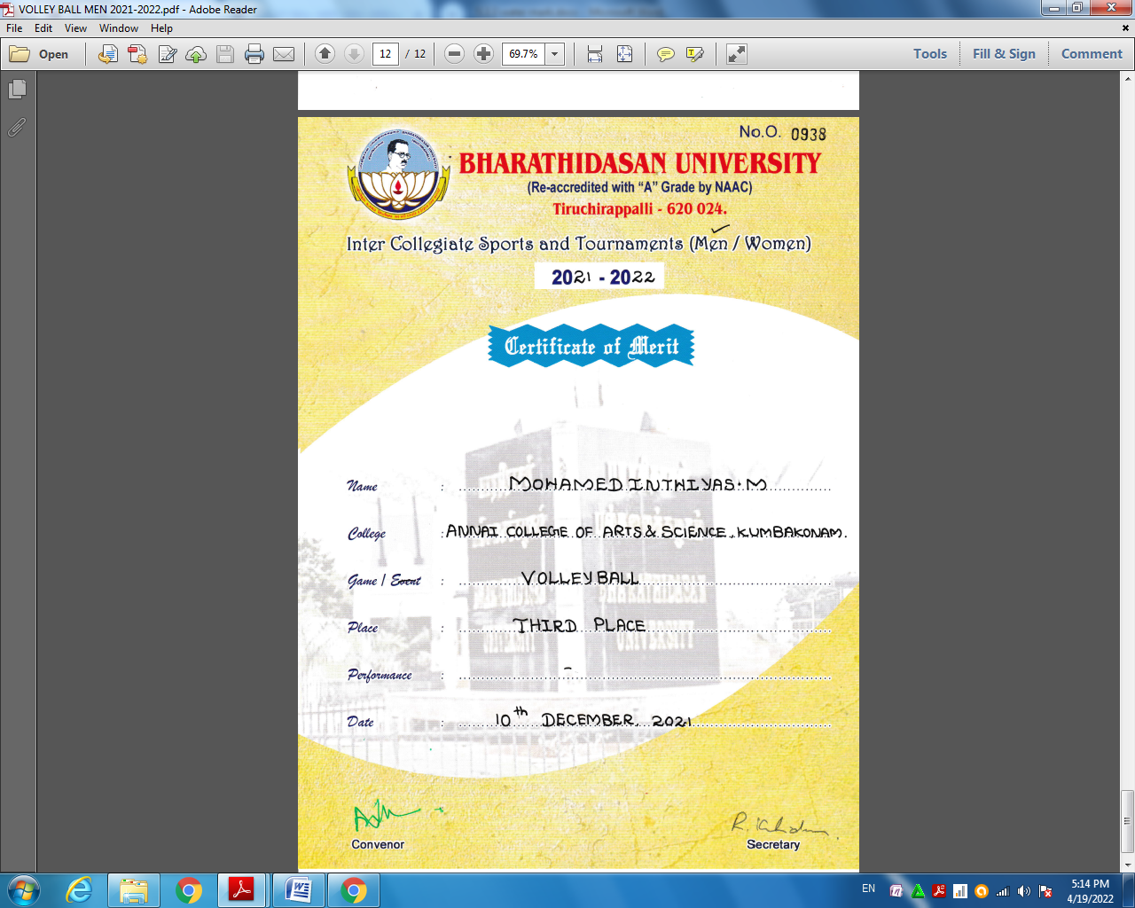

Our Annai College of Arts and Science Sports Female Students had Won the Volley Ball Match at Bharathidasan Unversity, Thiruchrapalli on 6TH &7TH December 2021.

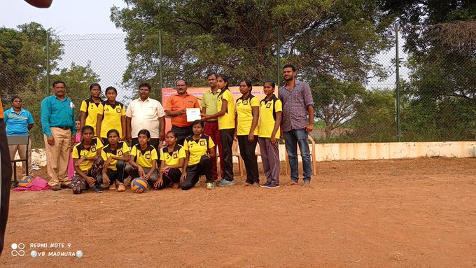

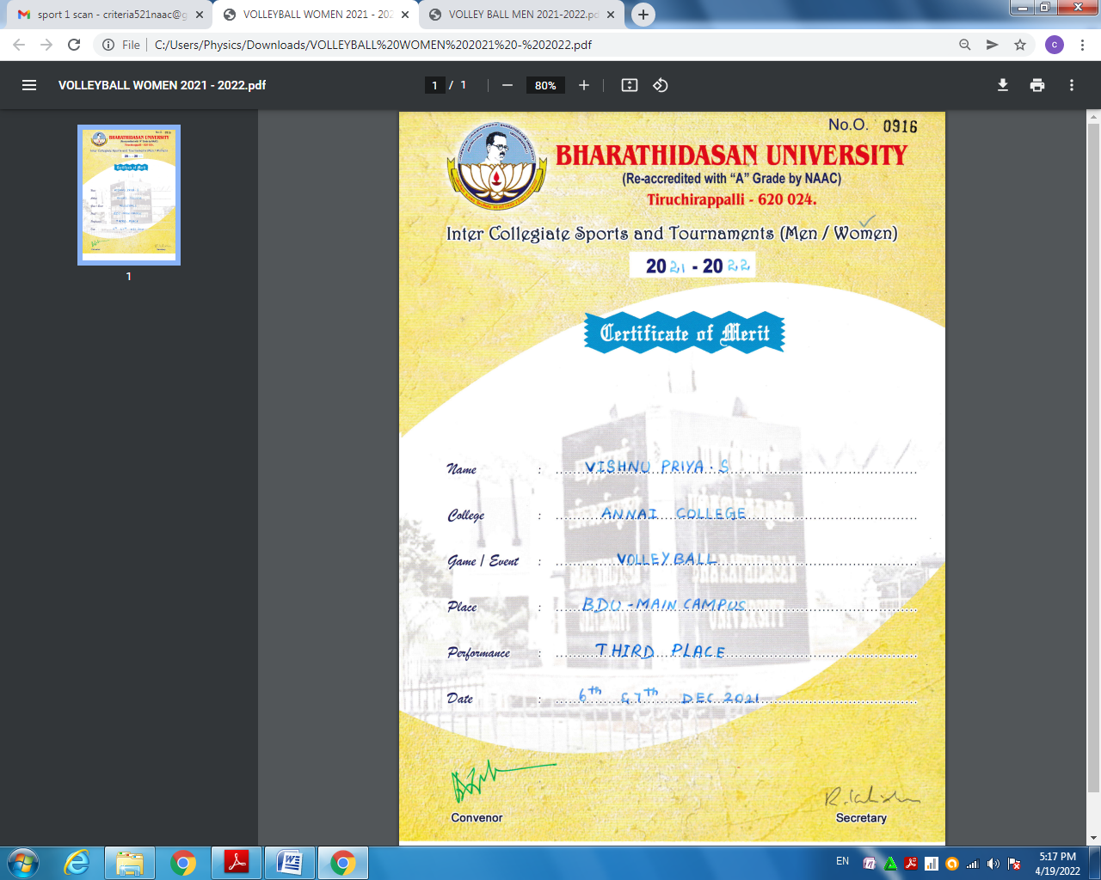
Certificate for Sports Students had Won the Volley Ball Match at Bharathidasan Unversity, Thiruchrapalli on 10TH December 2021.

