

ANNAI COLLEGE OF ARTS AND SCIENCE

BHARATHIDASAN UNIVERSITY

SUPPORTING DOCUMENT FOR 5.1.2

INSTITUTION FREE SEATS AND FEE CONCESSION FORM

Institution Free Seat and Fee Concession form
Trust form for free seat
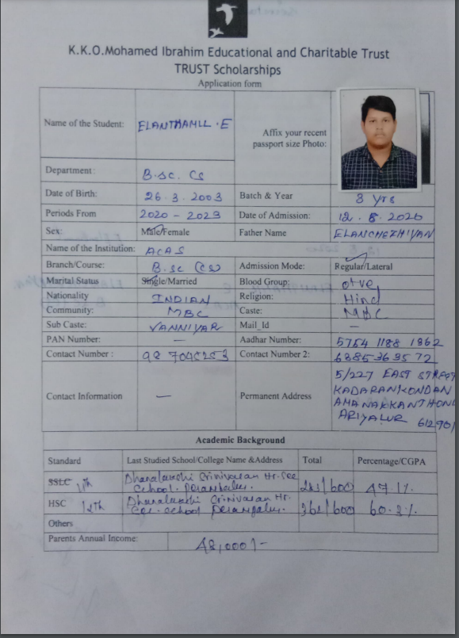

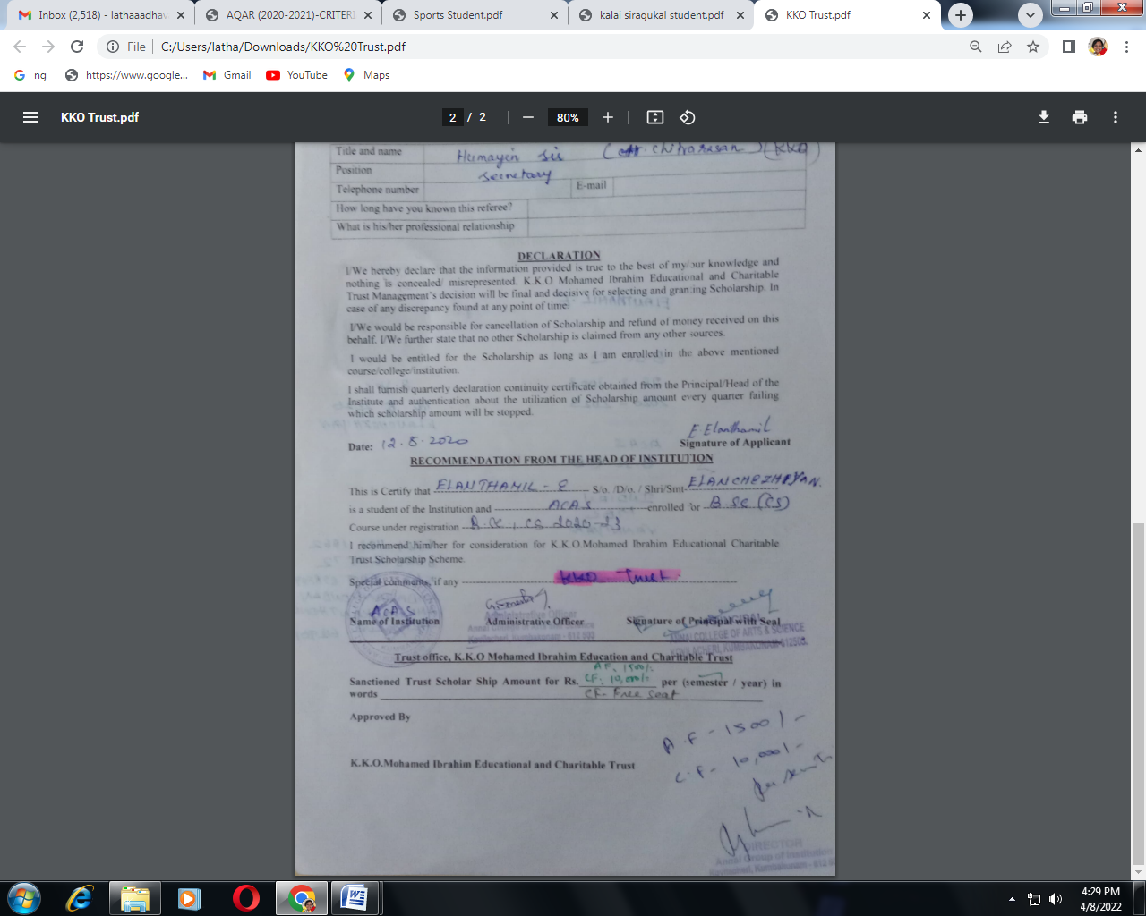

Sports Students Free Seats
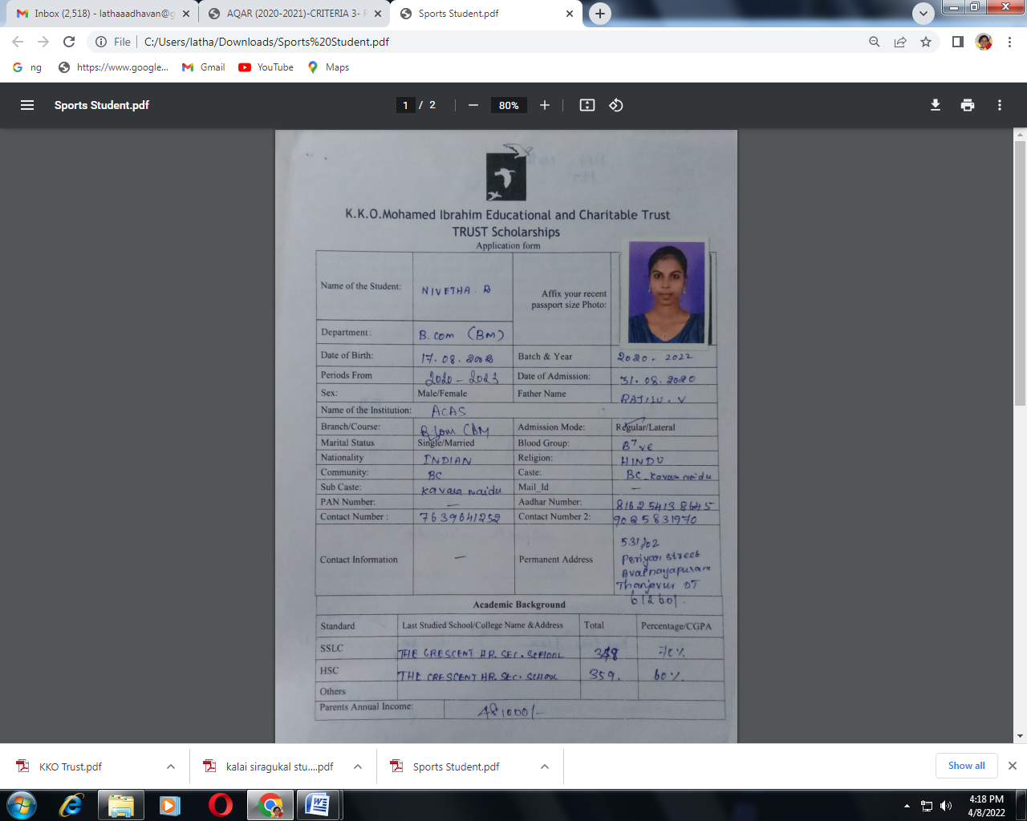

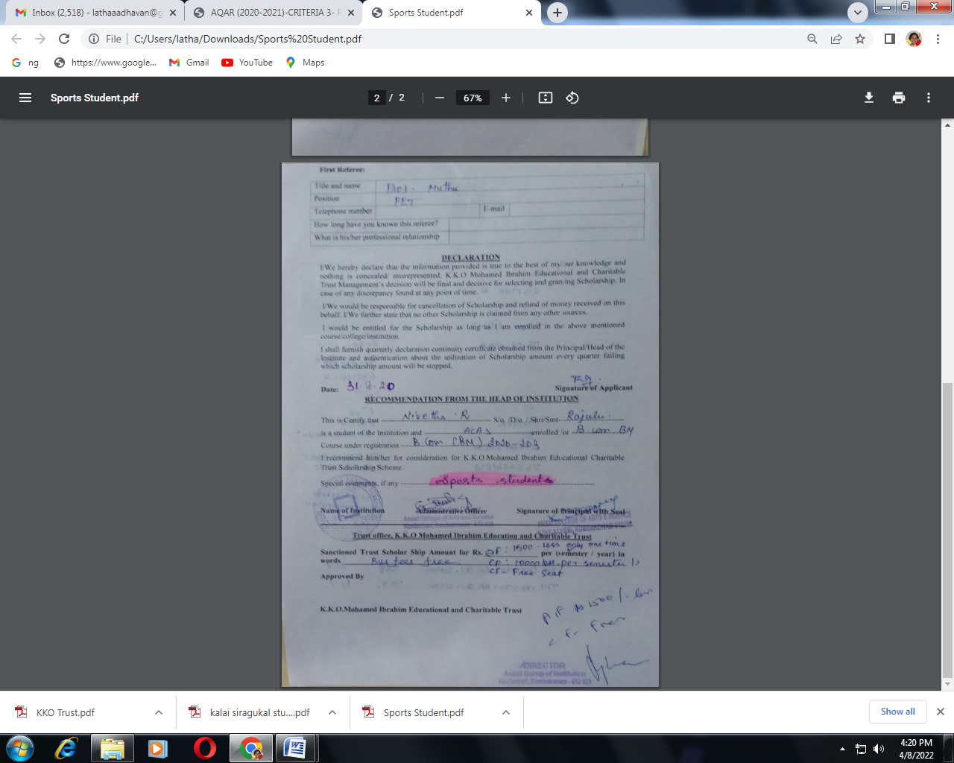
Course fee free for Cultural Students

