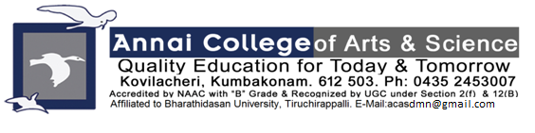

ANNAI COLLEGE OF ARTS AND SCIENCE

BHARATHIDASAN UNIVERSITY

Supporting Document 5.1.3

Capacity building and skills enhancement initiatives taken by the institution

Skill Enhancement: 5 day’s workshop on Placement Training from 17.12.2021 to 22.12.2021. Mr. Nayeem A Khan, Regional Manager -HR Campus Training and Recruitment wing TCS-Chennai provide training to the students.
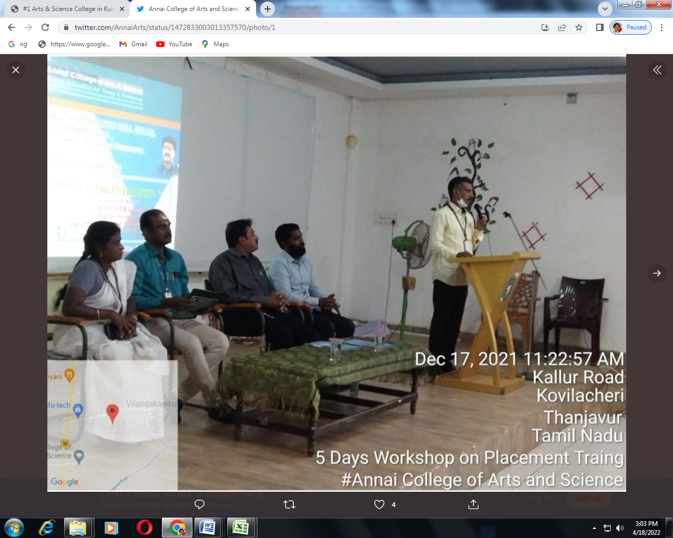
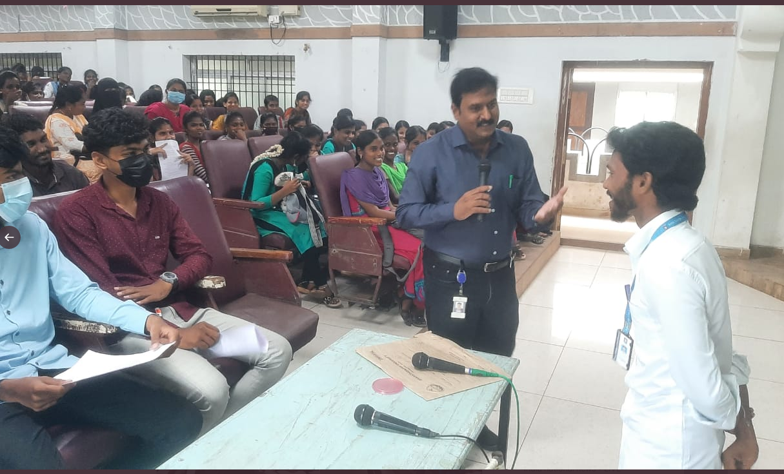
5-Day’s International Entrepreneurship Development & Career Enrichment from 26th July to 30th July 2021 through Online (Webinar)
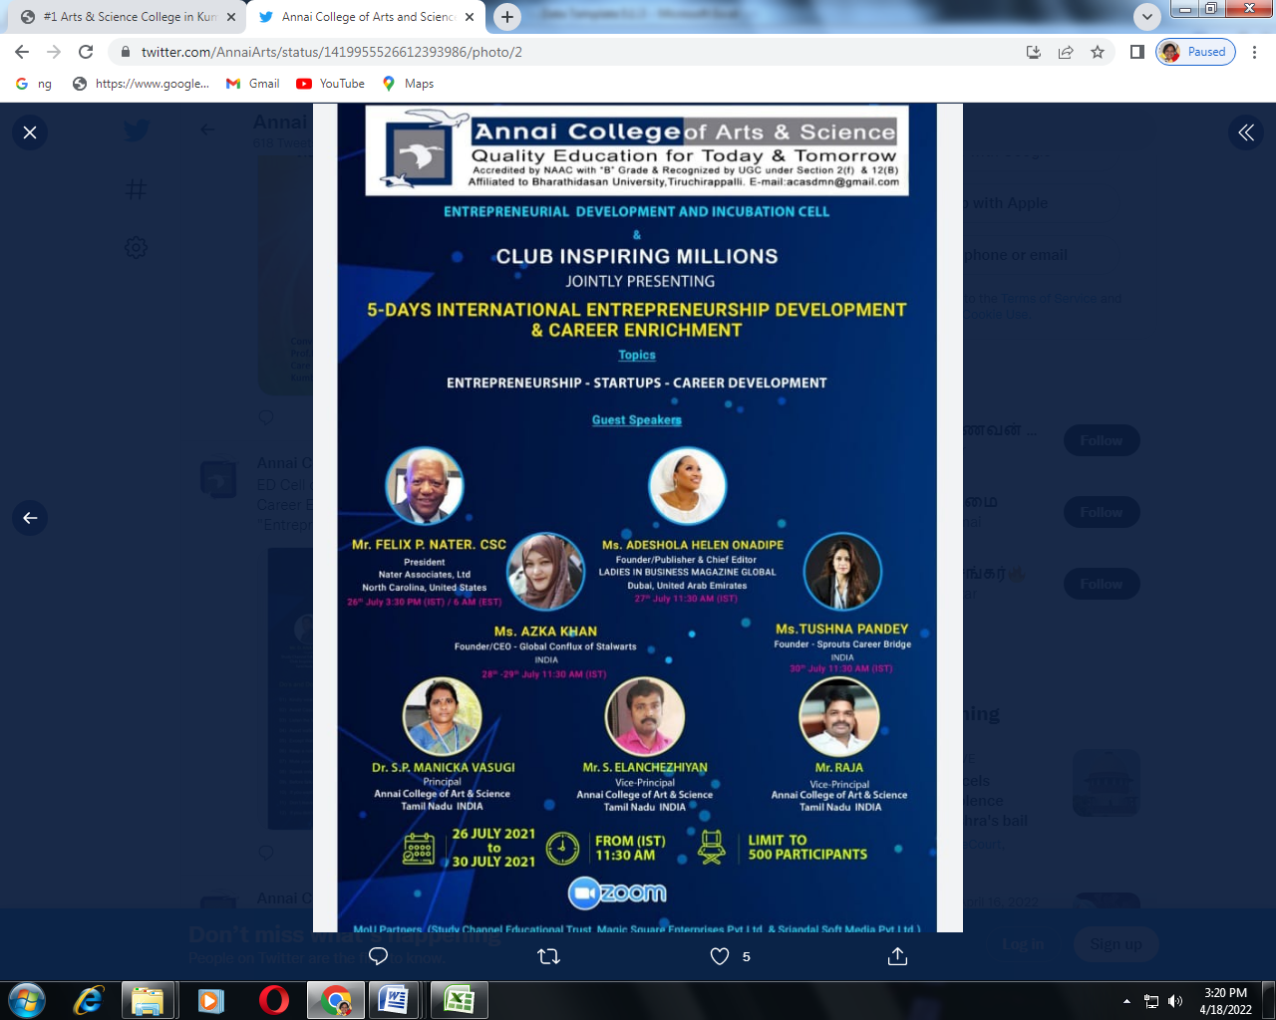
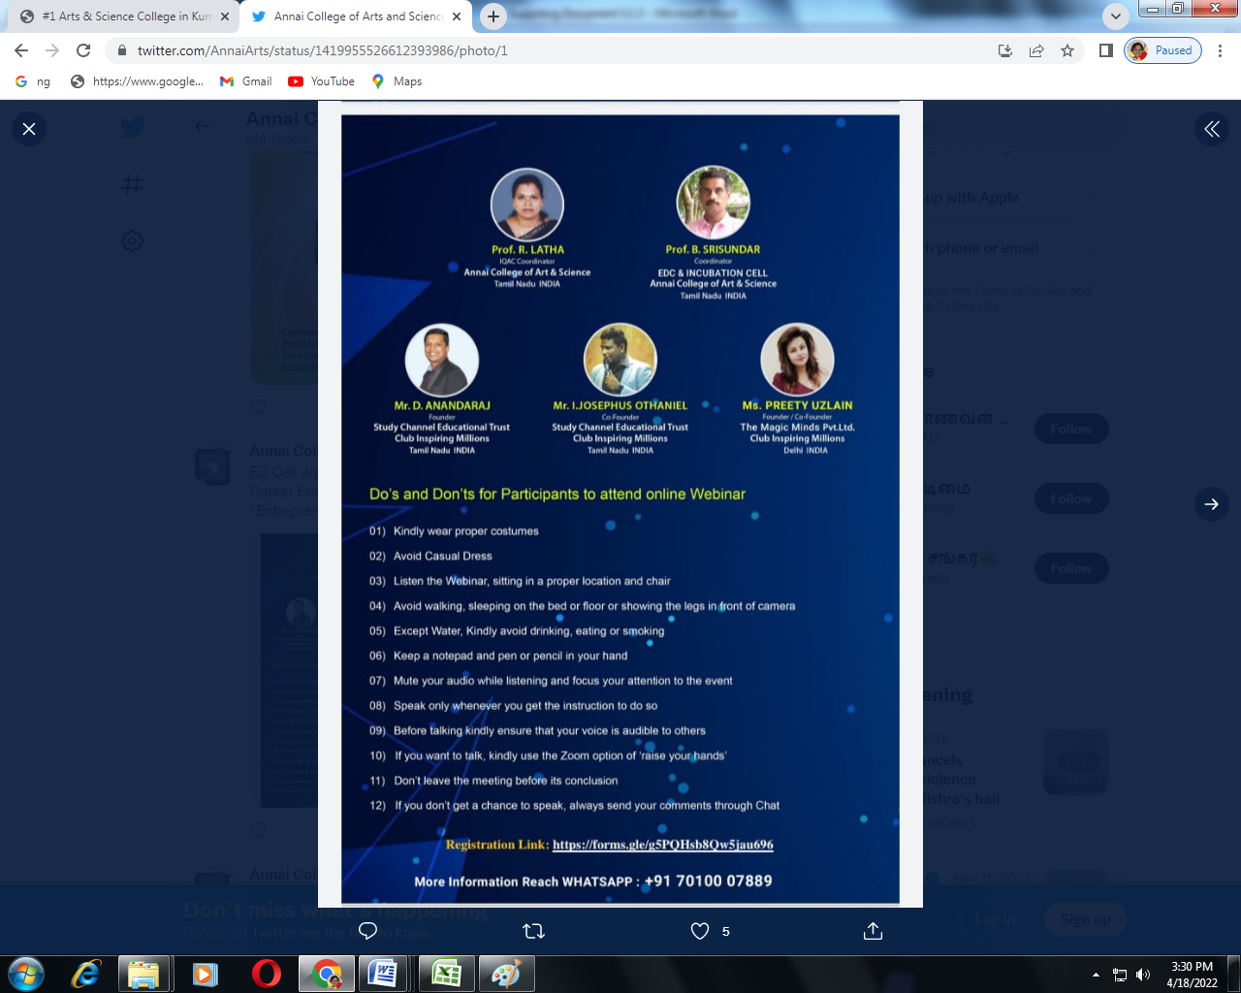

Yoga Practice for Students on 29.09.2021. Dr. G. Karthiga from Annai College of Naturopathy and Yoga Science instructed yoga practice to the students
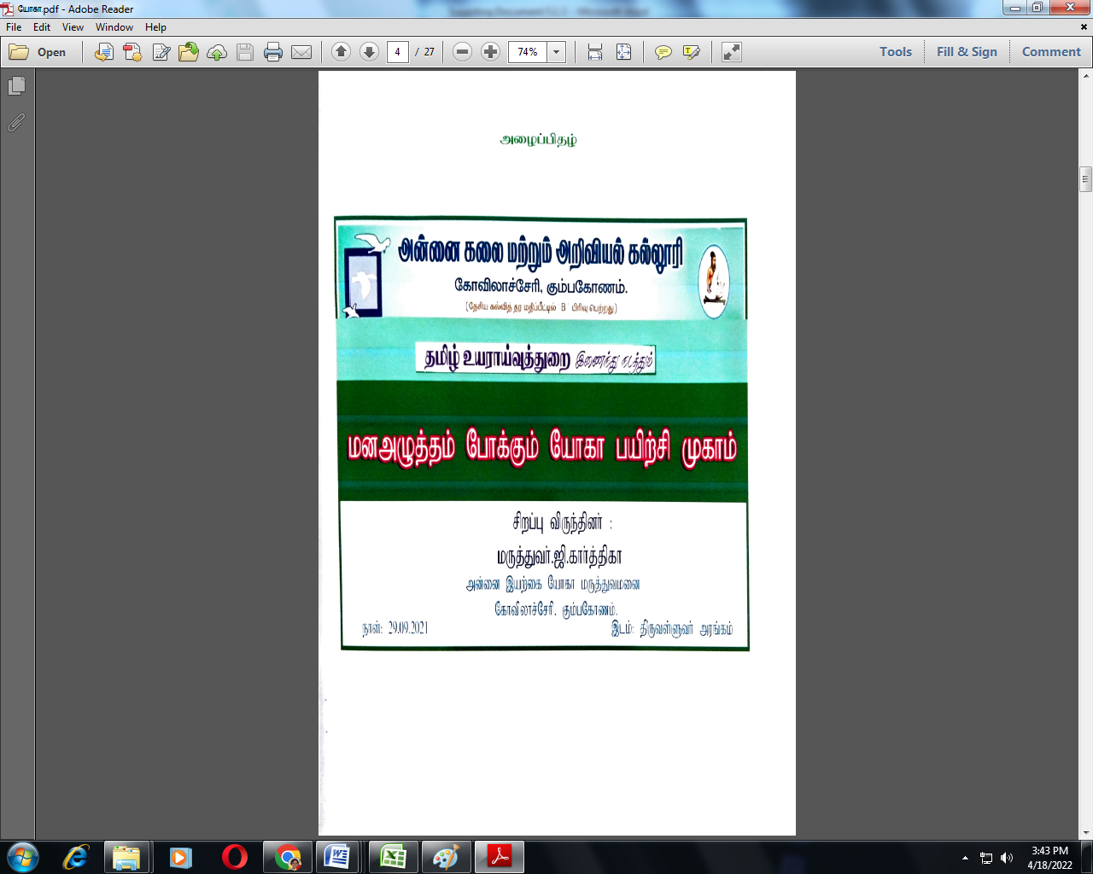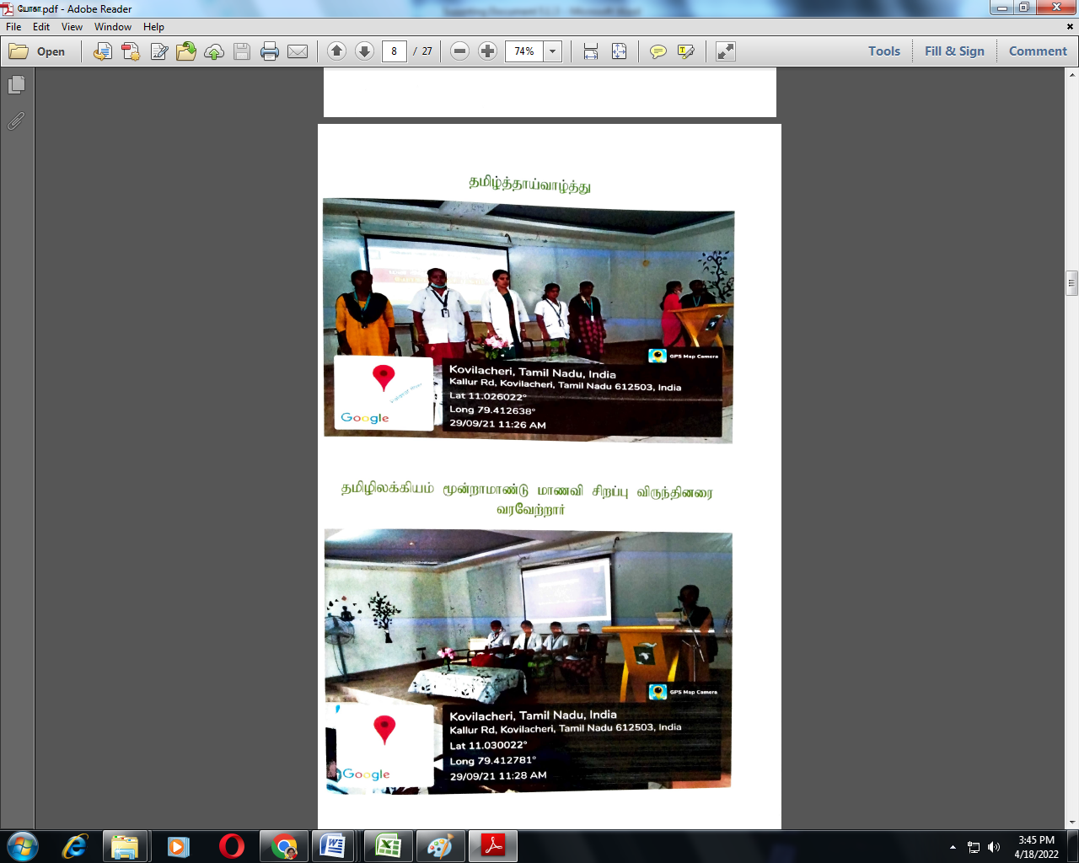
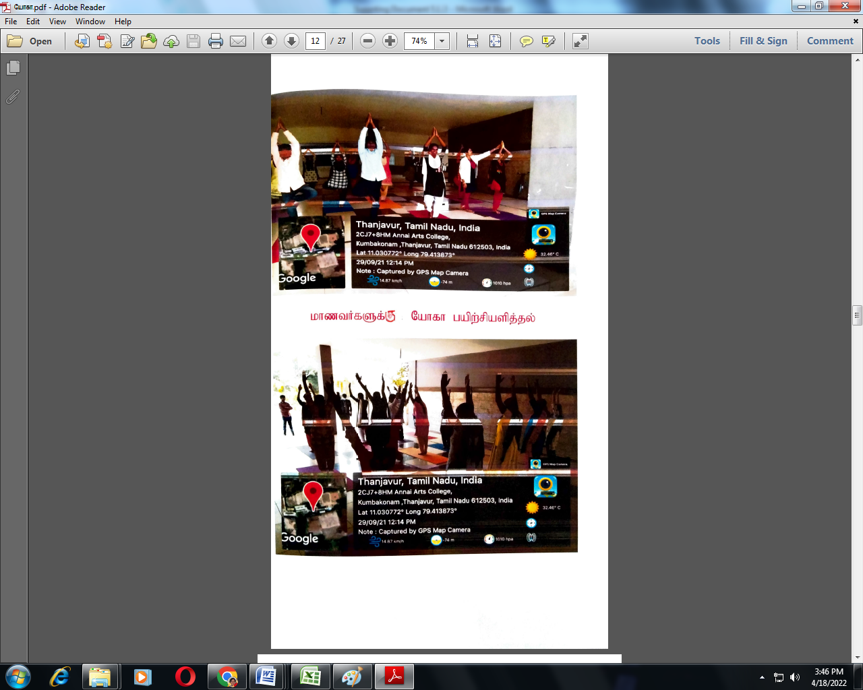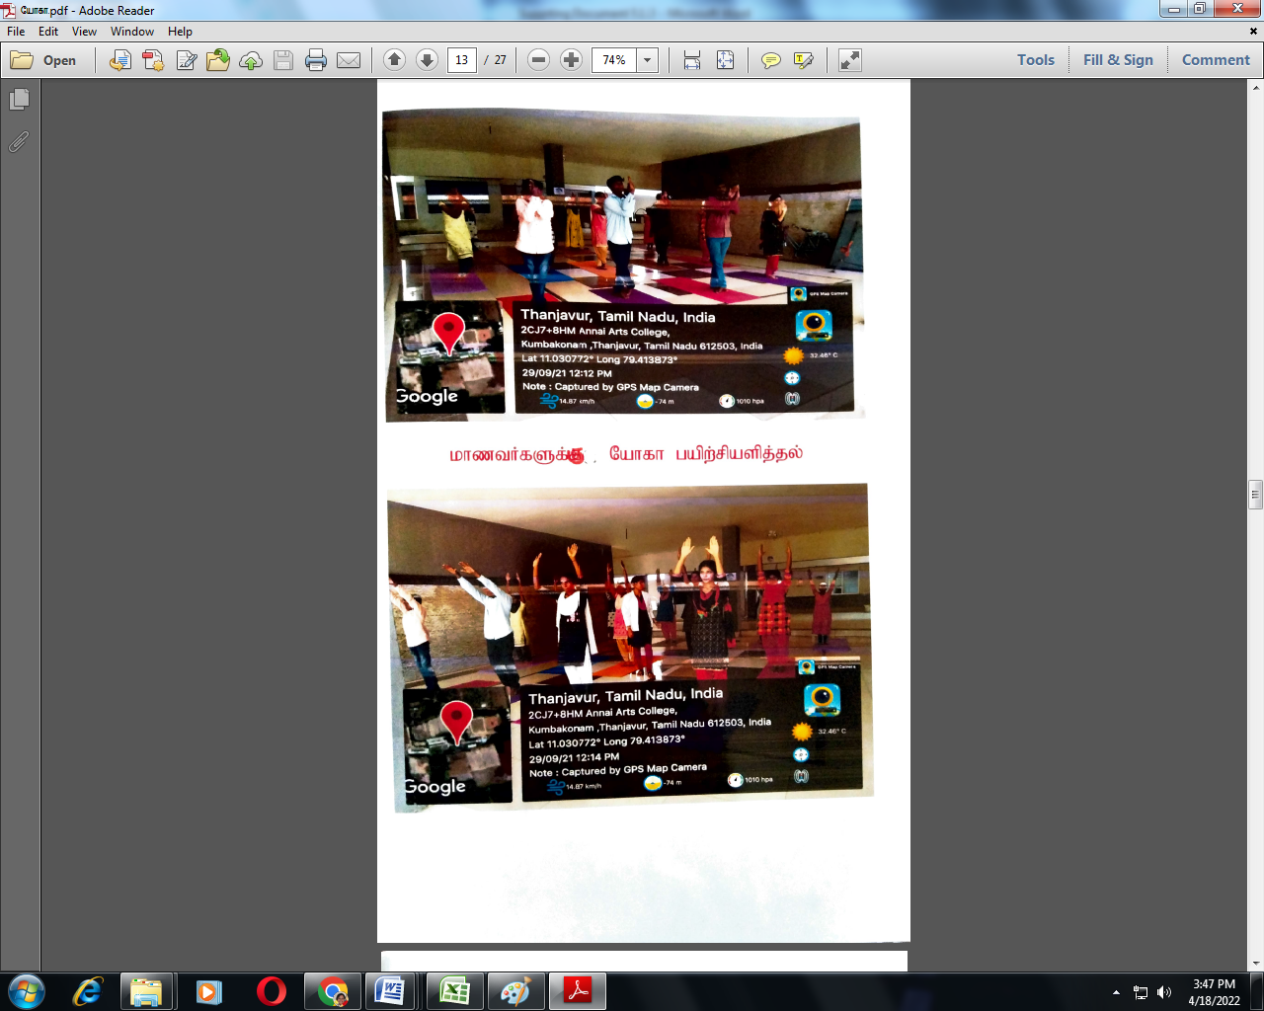
Language and Communication Skills (LSRW-Method) one month Certificate course provided for the students from 1.09.2021 to 20.10.2021.
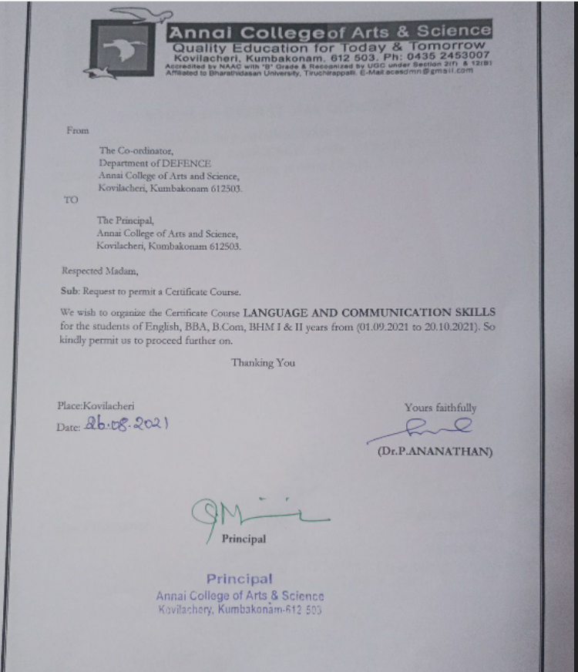

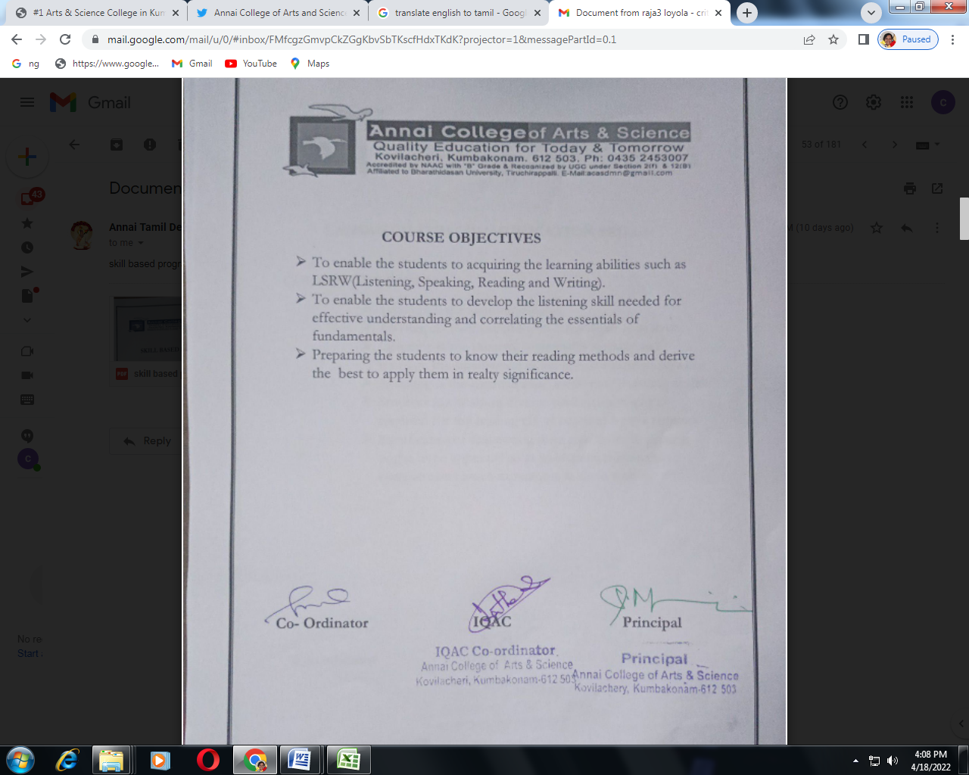

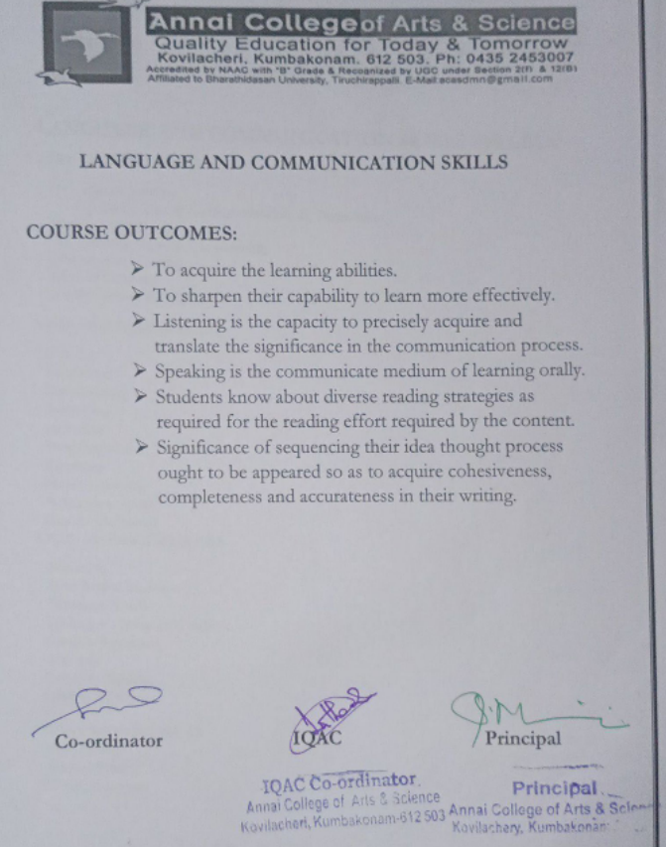

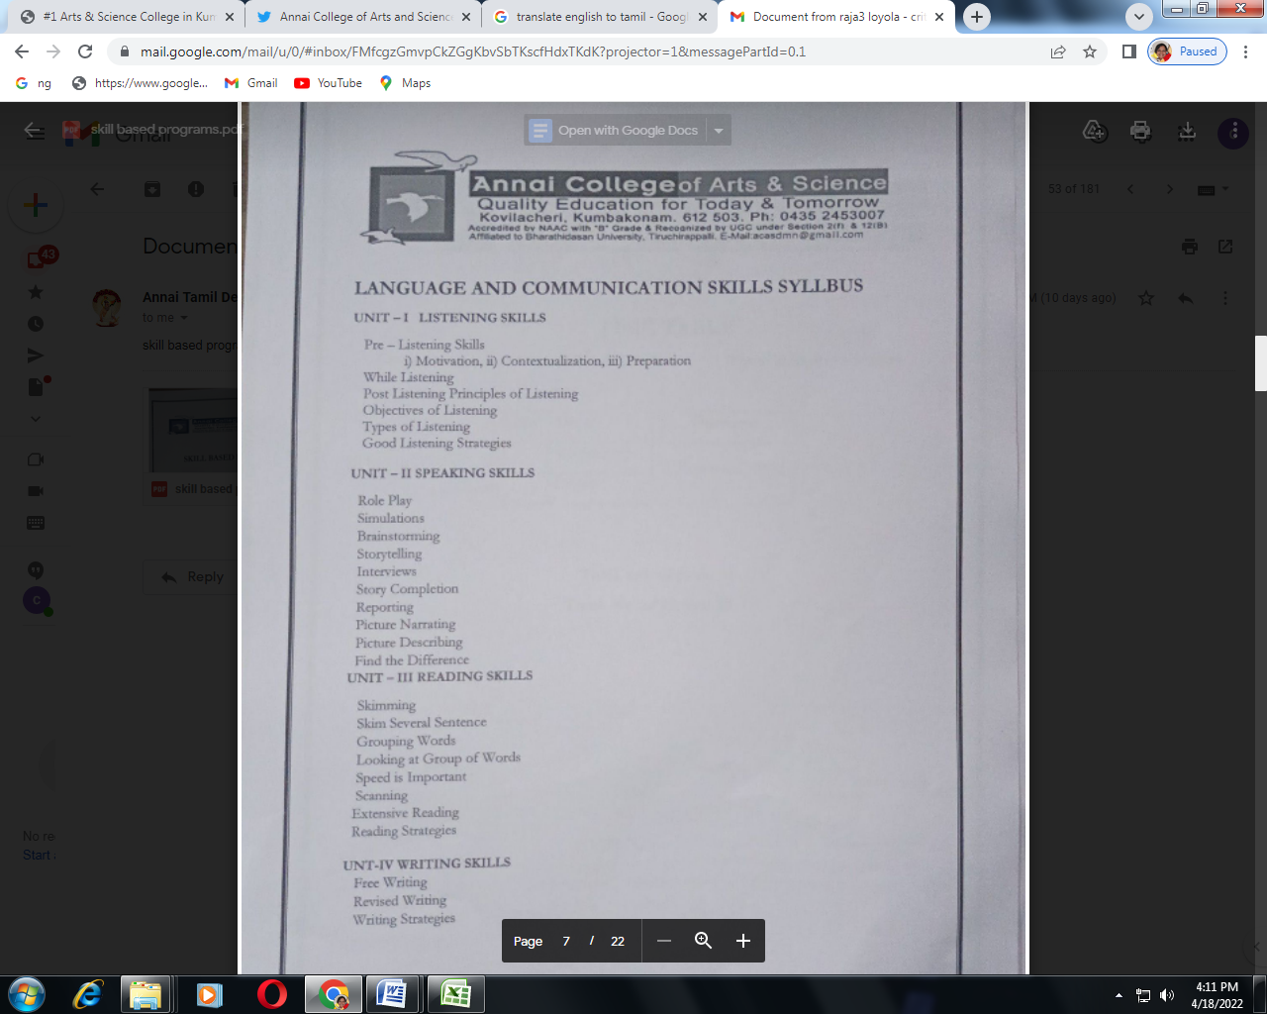

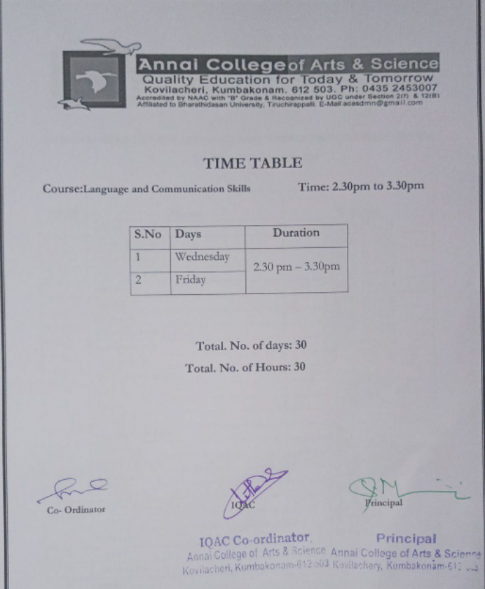

Students in LSRW Class
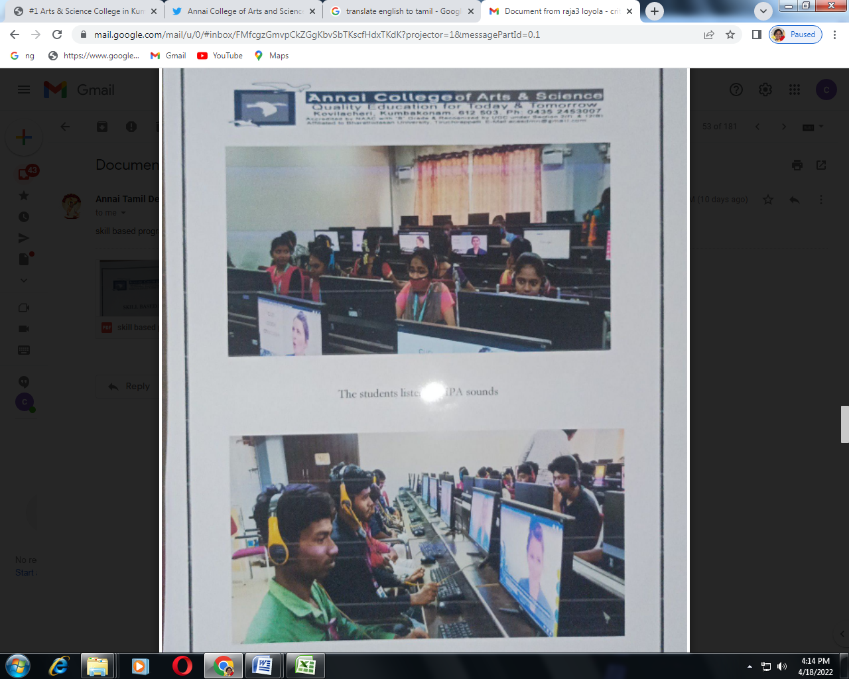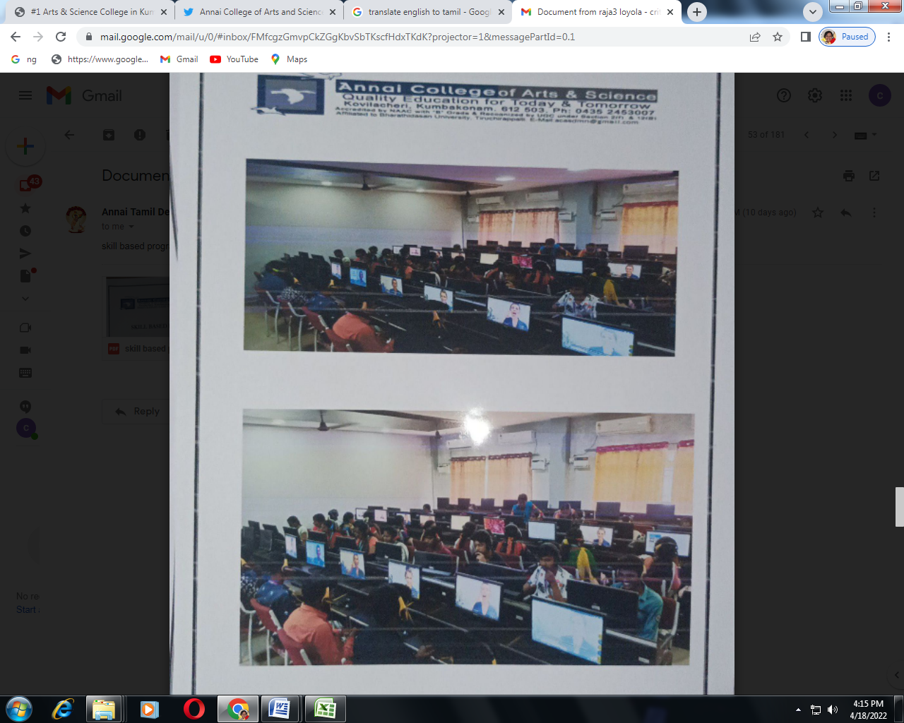

Self Defence (Karate) workshop and its Practical Demonstration from 02.03.2021 to 8.03.2021
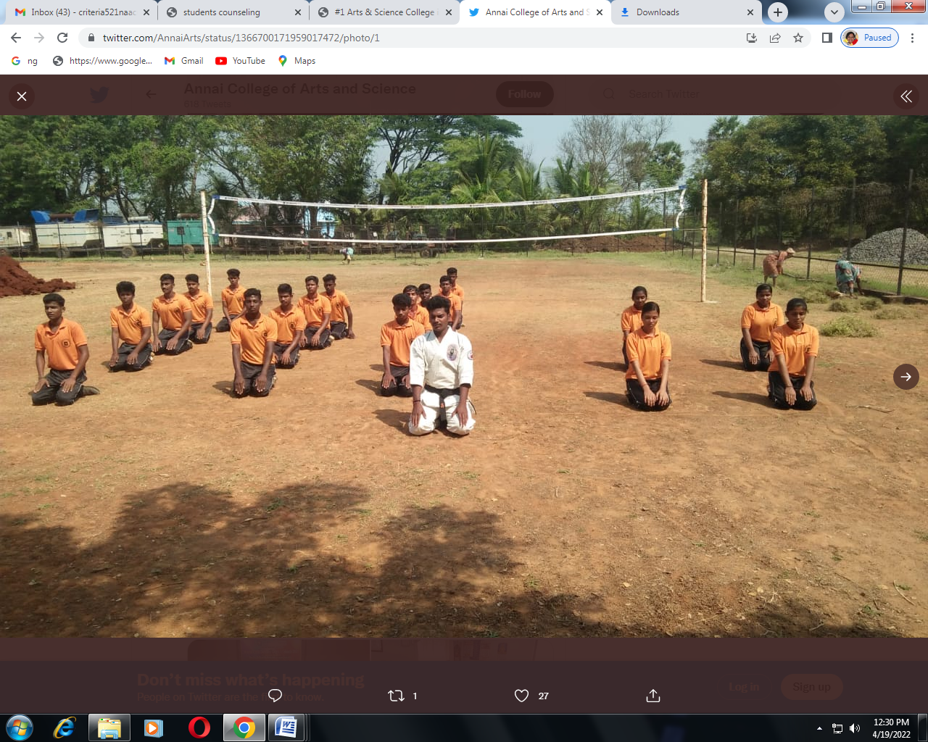
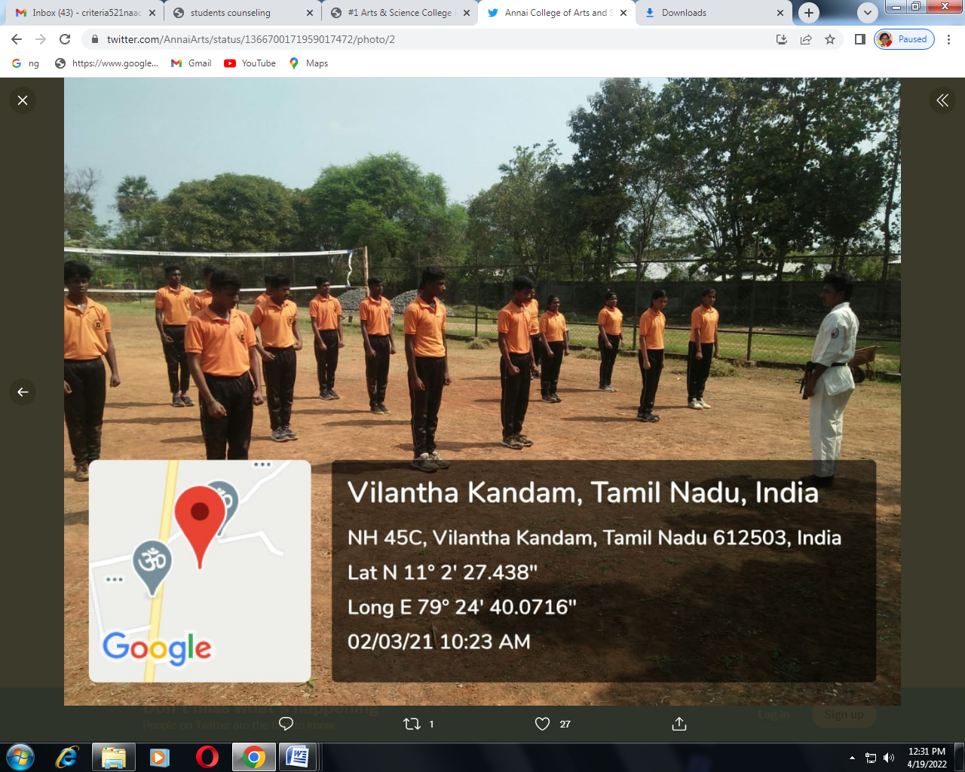
In Collaboration with ICT Academy conducted “LEARNATHA 2021” around 327 students were registered, participated and benefited from 17.08.2021 to 30..09.2021
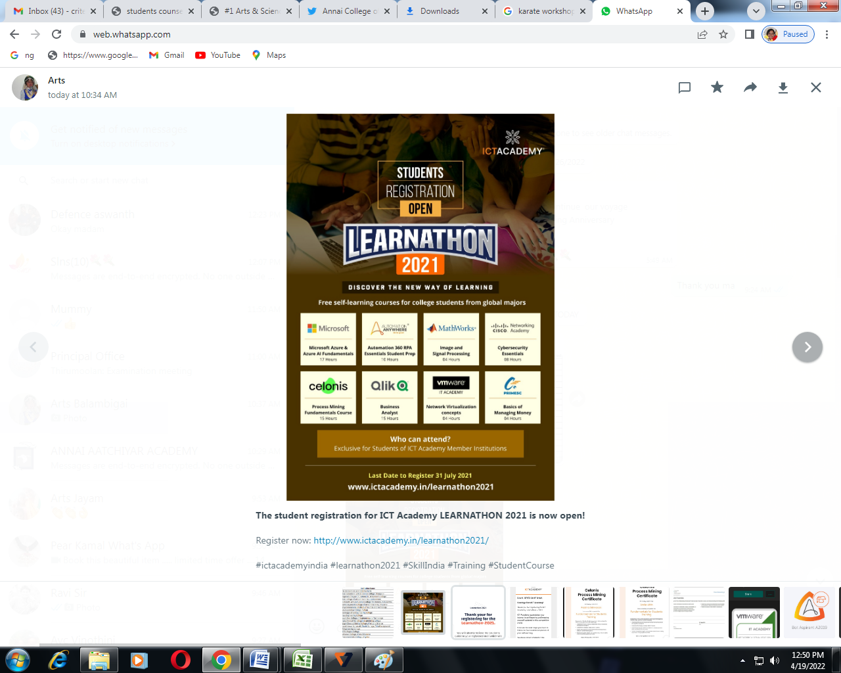
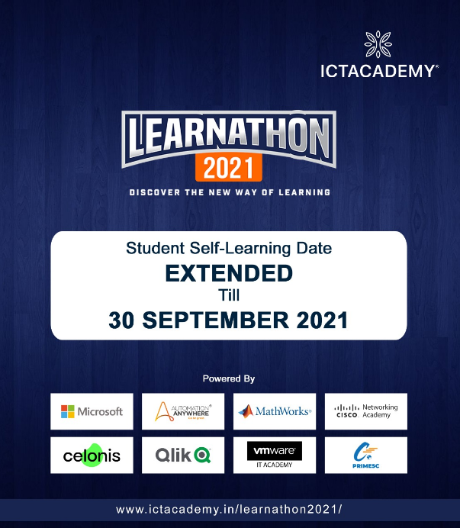
Our Institution ICT Academy ID and Registered students are marked as PINK for“LEARNATHA 2021”
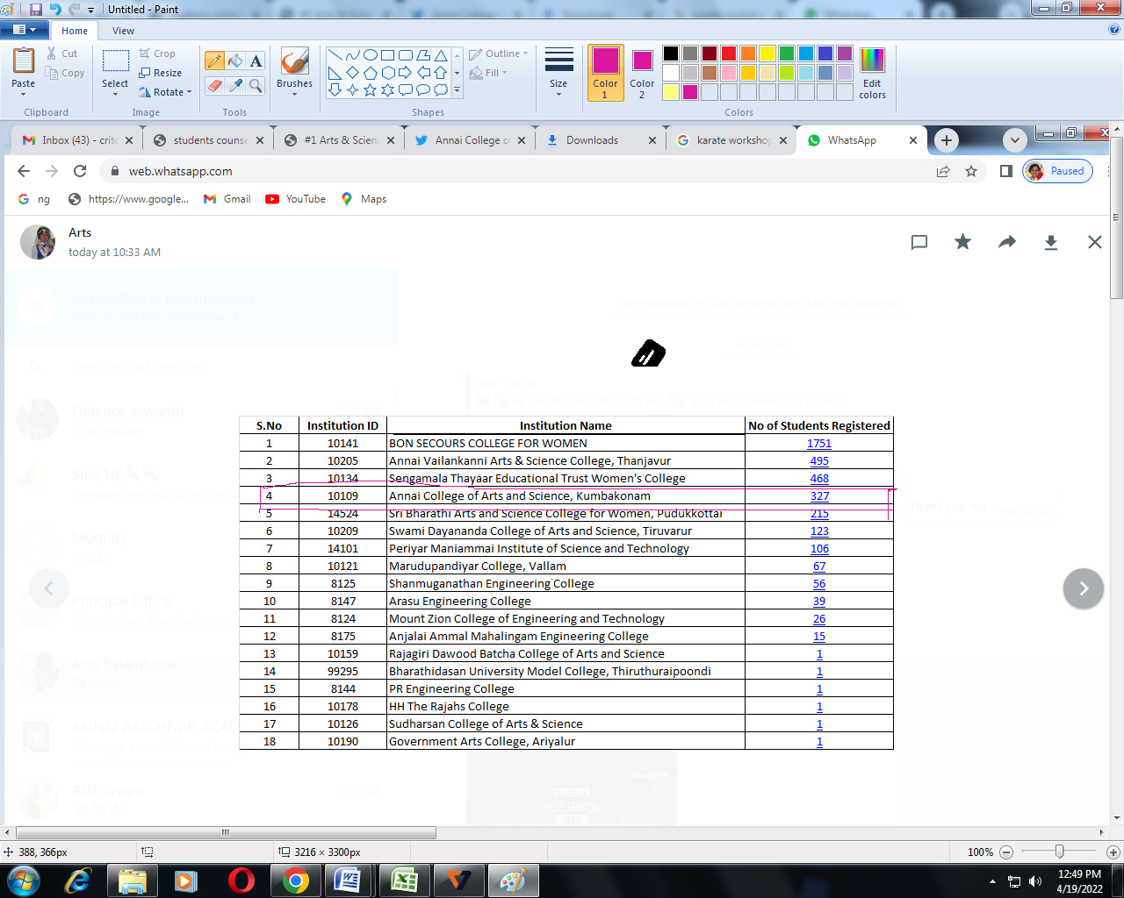

Registered Students Form
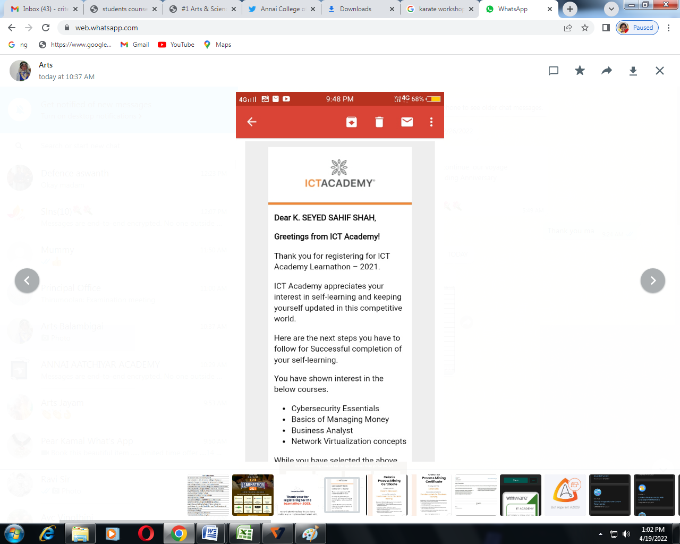

Certificate of the Students
