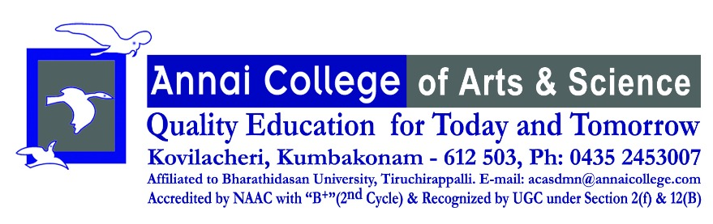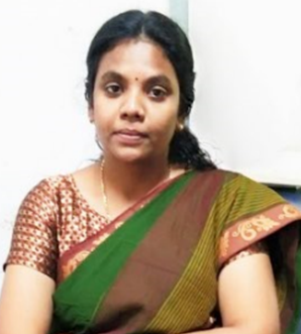
Staff Profile
Name of the Faculty: | Dr.R.Jothi Priya
Department | Business Administration
Qualification | MBA,M.Phil,PhD
Date of Birth | 15.10.1985
Date of Joining in this Institution
Total Years of Teaching Experience | 8 years
E-Mail | sivasaimitra@gmail.com
Mobile | 9361208250
NET/SELT | ---
Area of Specialization | HRM
No. of Ph.D/M.Phil Guided | M.PhilPh.D
No. of Ph.D/M.Phil Guided | Completed GuidingCompleted Guiding
No. of Ph.D/M.Phil Guided | -- --- ----
Positions Held | Assistant Professor
No. of Programmes Organized | 04
No of National/International Conference(Conducted/Attended) | National International
No of National/International Conference(Conducted/Attended) | Cond.. Att.. Cond.. Att..
No of National/International Conference(Conducted/Attended) | 01
No. of Workshop/Seminars /FDP(Conducted/Attended) | Workshops/FDP Seminars
No. of Workshop/Seminars /FDP(Conducted/Attended) | Cond.. Att.. Cond.. Att..
 | 3,7 13
Any Awards Received related to Academic/Club | Awards – 3
No. of Publications Journals/Books | Books –-Chapters – 3 Journals - 8

Director

