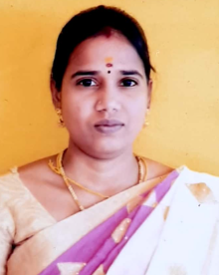
Staff Profile
Name of the Faculty: | J Priyanga
Department | Business Administration
Qualification | MBA
Date of Birth | 03.04.1993
Date of Joining in this Institution | 01.11.2024
Total Years of Teaching Experience | 1 years 6 month
E-Mail | priyangadeepakmba@gmail.com
Mobile | 9080488354
NET/SELT | ---
Area of Specialization | Finance
No. of Ph.D/M.Phil Guided | M.PhilPh.D
No. of Ph.D/M.Phil Guided | Completed GuidingCompleted Guiding
No. of Ph.D/M.Phil Guided | -- --- ----
Positions Held | Assistant Professor
No. of Programmes Organized | ---
No of National/International Conference(Conducted/Attended) | National International
No of National/International Conference(Conducted/Attended) | Cond.. Att.. Cond.. Att..
No of National/International Conference(Conducted/Attended) | --
No. of Workshop/Seminars /FDP(Conducted/Attended) | Workshops/FDP Seminars
No. of Workshop/Seminars /FDP(Conducted/Attended) | Cond.. Att.. Cond.. Att..
 | --- --
Any Awards Received related to Academic/Club | Awards – --
No. of Publications Journals/Books | Books –-Chapters – -- Journals - --

Signature of the Staff Signature of Principal

